Avalanche

Subrata Paul

1/23/2021

## Preparedness

Shovel, Beacon and Probe are coded as ordinal variables. The variables are coded as

|  |  |
| --- | --- |
| None | 0 |
| Some | 1 |
| All | 2 |

Missing values for these variables are imputed to be the mean of the observations within corresponding Tourer category.

#### Preparedness score 1

We define preparedness as the sum of three variables Shovel, Beacon, and Probe. Comparison in preparedness in three Tourer category is given in the following figure.

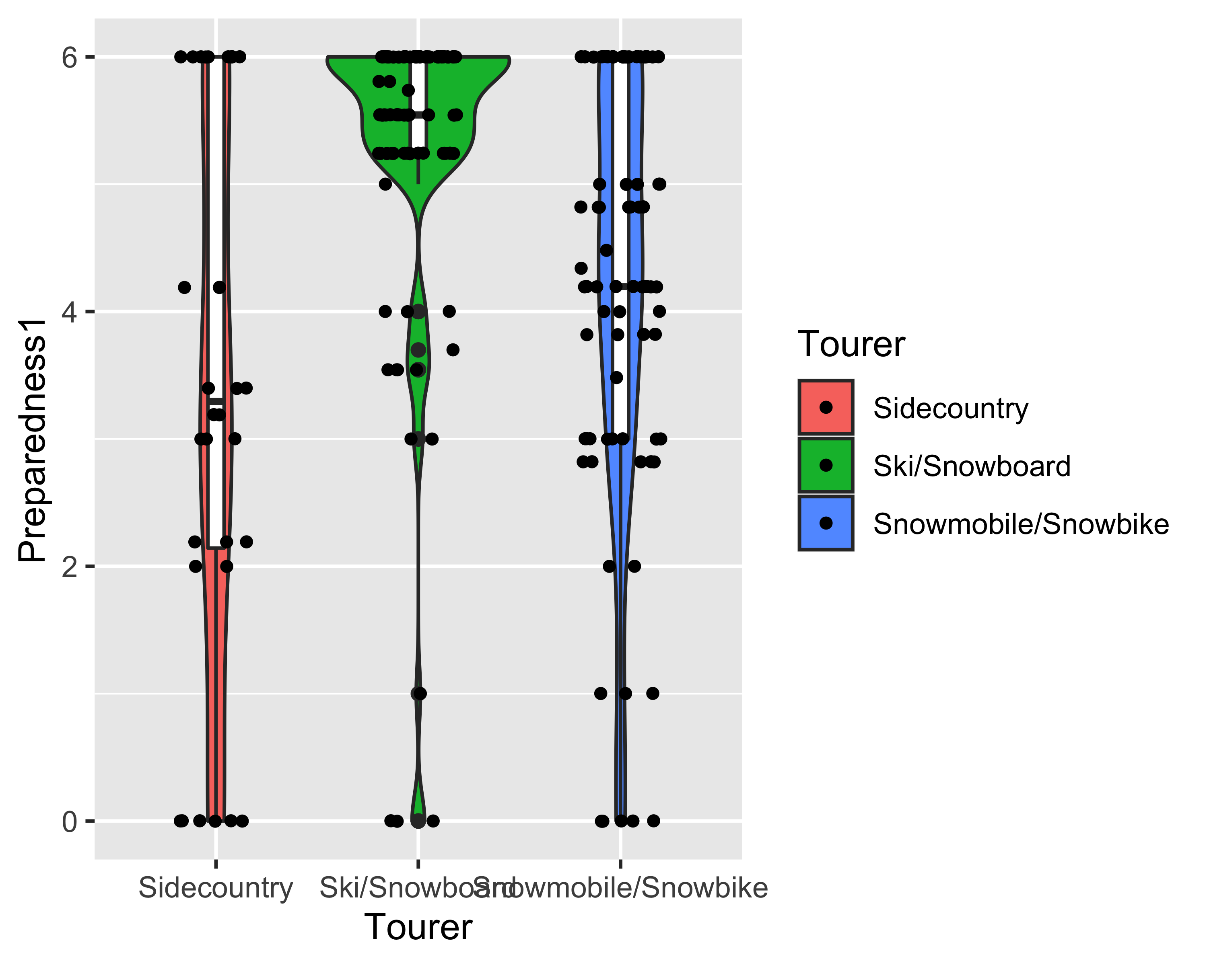

#### Observations:

1. Ski/Snowboarders are one an aveerage more prepared other than few exception.
2. Preparedness of people in sidecountry group are evenly distributed meaning that there are people who are well prepared, somewhat prepared and not-prepared.
3. Most of the people were somewhat prepared on the Snowmobile group.

### Preparedness 2

Number of people in a group also contributes to preparedness. We can also define preparedness as the product of Shovel + Beacon + Probe and number of people in the group. For example, if a group have three persons, all of them took shovel, some of them took probe and none of them took beacon the group will have $3×(2+1+0)=9$ in prepardness score. Comparison of the groups in this scoring is given below.

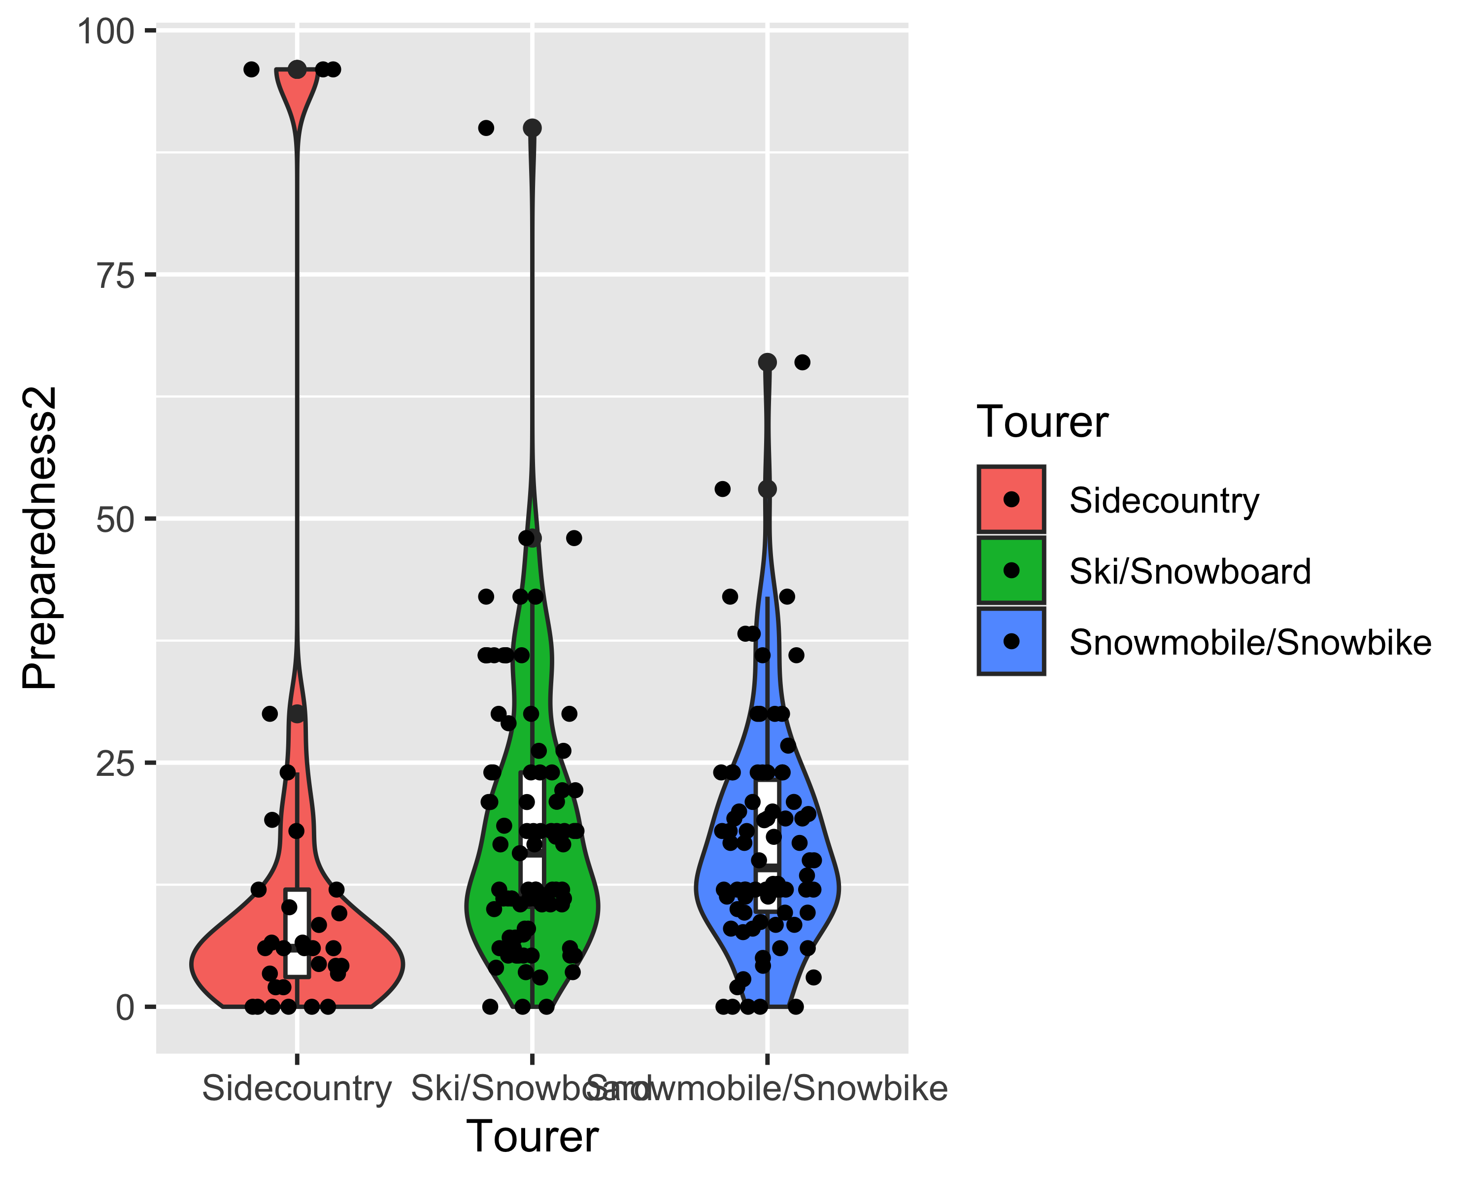

### Preparedness 3

A potential problem in this scoring is that it is influenced by the size of the groups. We can overcome this problem converting the party size as

|  |  |
| --- | --- |
| 1 | 1 |
| 2-4 | 2 |
| >4 | 3 |

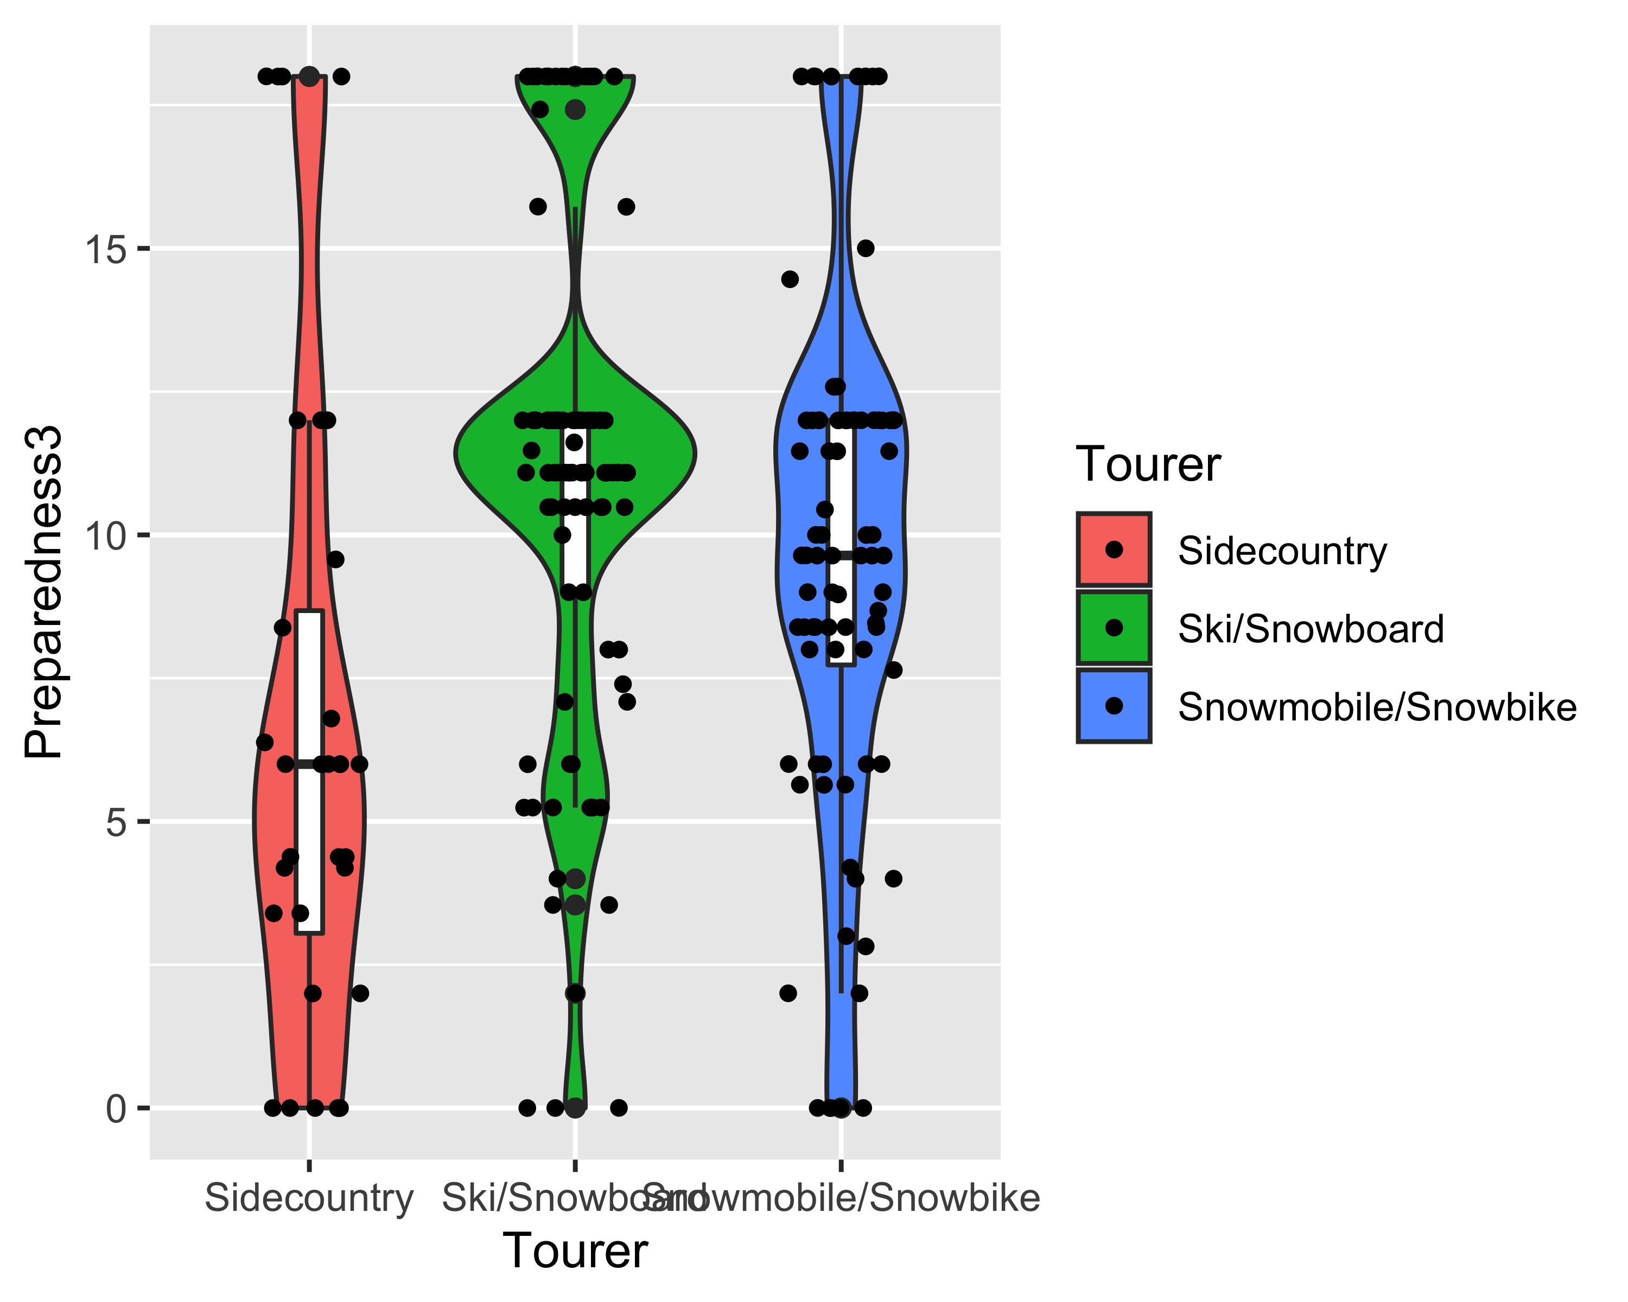

### Preparedness 4

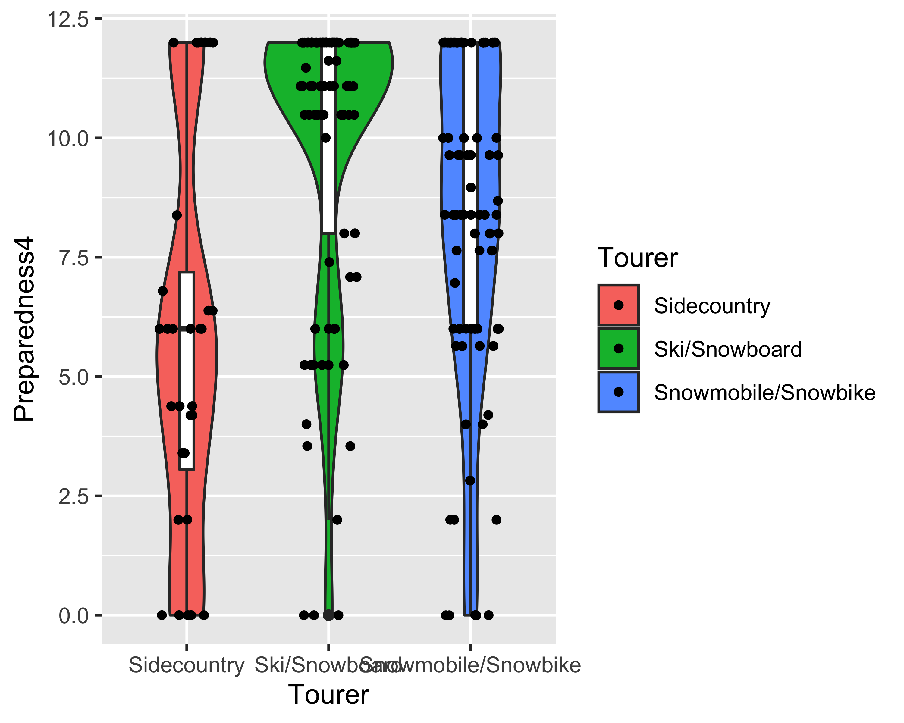

## Analysis of variance

### Bartlett test homogeneity of variance

Bartlett test of homogeneity of variances

data: Preparedness1 by Tourer Bartlett’s K-squared = 14.278, df = 2, p-value = 0.0007934

Bartlett test of homogeneity of variances

data: Preparedness2 by Tourer Bartlett’s K-squared = 40.223, df = 2, p-value = 1.844e-09

Bartlett test of homogeneity of variances

data: Preparedness3 by Tourer Bartlett’s K-squared = 2.4318, df = 2, p-value = 0.2964

Bartlett test of homogeneity of variances

data: Preparedness4 by Tourer Bartlett’s K-squared = 3.2074, df = 2, p-value = 0.2012

### Fligner-Killeen’s test

##   
## Fligner-Killeen test of homogeneity of variances  
##   
## data: Preparedness1 by Tourer  
## Fligner-Killeen:med chi-squared = 24.832, df = 2, p-value = 4.054e-06

##   
## Fligner-Killeen test of homogeneity of variances  
##   
## data: Preparedness2 by Tourer  
## Fligner-Killeen:med chi-squared = 2.4287, df = 2, p-value = 0.2969

##   
## Fligner-Killeen test of homogeneity of variances  
##   
## data: Preparedness3 by Tourer  
## Fligner-Killeen:med chi-squared = 2.0704, df = 2, p-value = 0.3552

##   
## Fligner-Killeen test of homogeneity of variances  
##   
## data: Preparedness4 by Tourer  
## Fligner-Killeen:med chi-squared = 7.4828, df = 2, p-value = 0.02372

### Preparedness 1

The preparedness is statistically different in the three categories.

### Preparedness 2

We don’t have enough evidence to say that the preparedness is statistically different among the three groups.

### Preparedness 3

Preparedness is statistically different in three groups.

### Preparedness 4

### Tukey HSD test

The above table gives 95% confidence interval of difference in mean between groups.

### Welch one-way test

##   
## One-way analysis of means (not assuming equal variances)  
##   
## data: Preparedness1 and Tourer  
## F = 16.693, num df = 2.000, denom df = 76.244, p-value = 9.71e-07

##   
## One-way analysis of means (not assuming equal variances)  
##   
## data: Preparedness2 and Tourer  
## F = 0.22779, num df = 2.000, denom df = 73.908, p-value = 0.7968

##   
## One-way analysis of means (not assuming equal variances)  
##   
## data: Preparedness3 and Tourer  
## F = 9.4189, num df = 2.000, denom df = 81.252, p-value = 0.0002094

##   
## One-way analysis of means (not assuming equal variances)  
##   
## data: Preparedness4 and Tourer  
## F = 14.16, num df = 2.000, denom df = 80.648, p-value = 5.362e-06

### Overall comments on preparedness

Preparedness score 2 is heavily influenced by the party size and is unreliable. The Bertlett test for homogeneity of variance concludes that the preparedness scaore 1 and 2 does not satisfy the homogeneity of variance condition (p-vlaues: 0.0007934 and $1.844×{10}^{−9}$, respectively). The other two scores (Preparedness score 3 and 4) came to the same conclusion that preparedness in the tourer groups are significantly different from each other based on the results of one-way analysis of variance.

Since the preparedness score does not follow a normal distribution, a Fligner-Killeen’s test is more appropriate. According to the test, the most statistically appropriate score is the Preparedness score 3. Using the preparedness score the there is statistically significant difference (F = 11.56, p-value = $1.76×{10}^{−5}$) in preparedness between the tourer groups.

For the post-hoc analysis of Tukey HSD test on Preparedness3. According to the test, significant differences are found between Ski/Snowboard - Sidecountry (p-value = 0.0000105) and Snowmobile - Sidecountry (p-value = 0.00723) group. We don’t have enough evidence to claim that preparedness is significantly difference between the Snowmobile/Snowbike - Ski/Snowboard groups (p-value = 0.064).

A more robust test for possible violation from normality and equality of variance is the Welch one-way test. The Welch one-way test also confirms the above result.

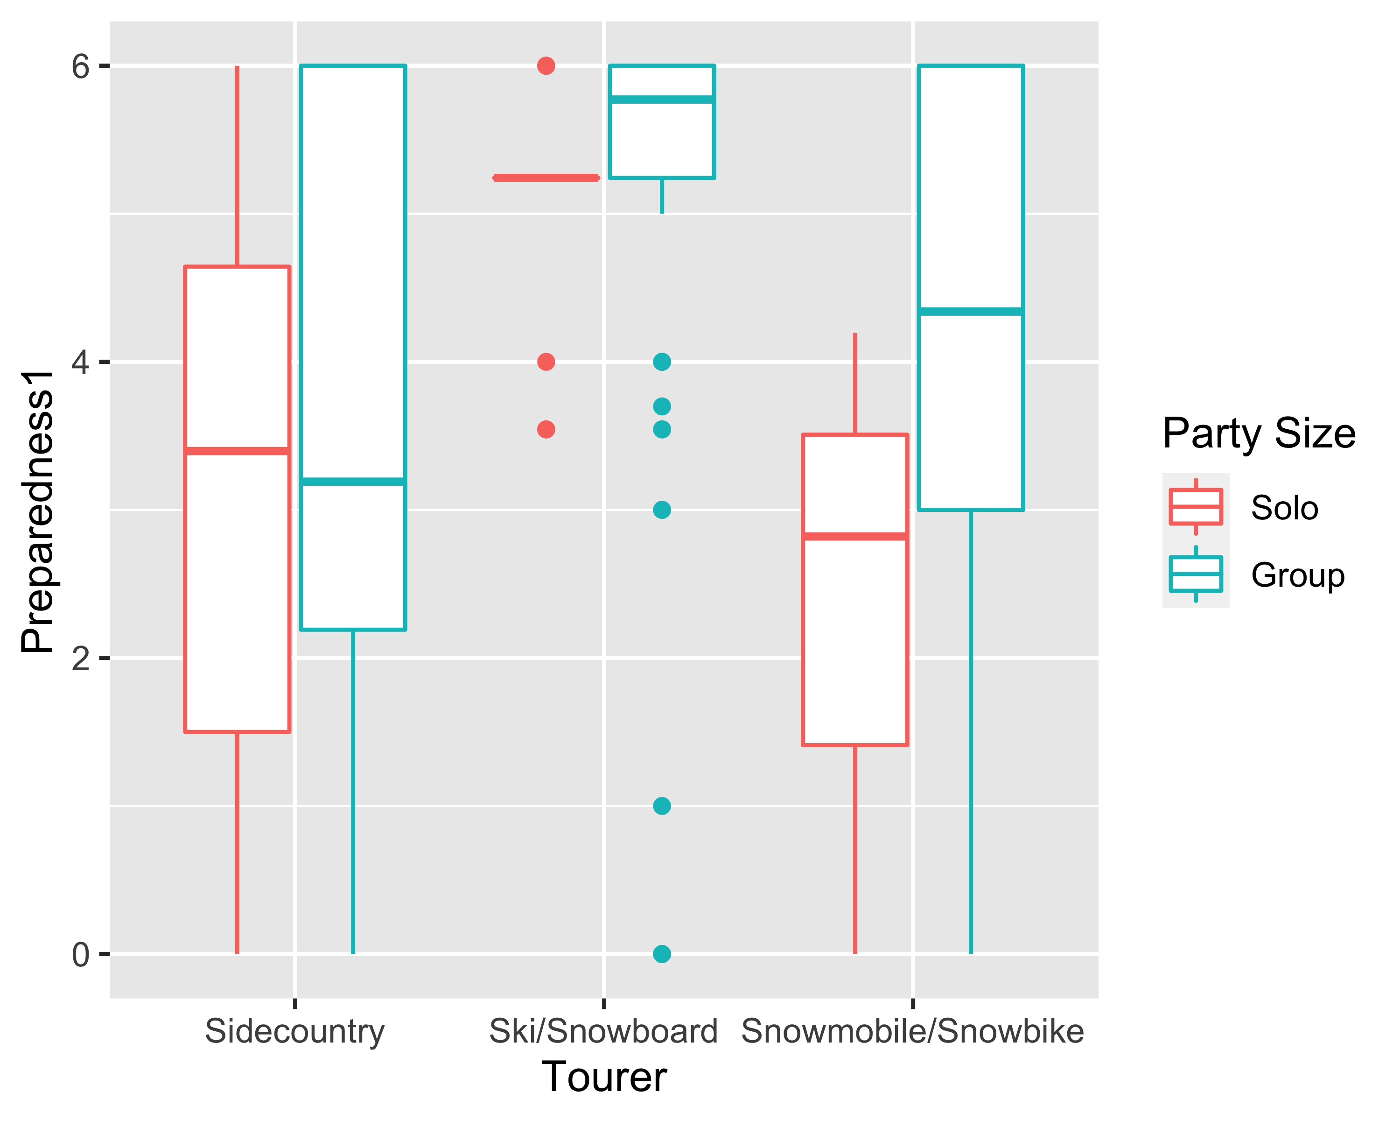

Test for homogeneity of variance

## Levene's Test for Homogeneity of Variance (center = median)  
## Df F value Pr(>F)   
## group 5 4.9856 0.0002523 ***  
## 199   
## ---  
## Signif. codes: 0 '***' 0.001 '**' 0.01 '*' 0.05 '.' 0.1 ' ' 1

So, the homogeneity assumption is violated. Also, the design is unbalanced since the number of observations vary too much. The ANOVA with Type-III sum of squares is prefered in such cases.

## Anova Table (Type III tests)  
##   
## Response: Preparedness1  
## Sum Sq Df F value Pr(>F)   
## (Intercept) 115.17 1 43.4450 3.826e-10 ***  
## Tourer 32.51 2 6.1317 0.002605 **   
## Total_in_party_cat_bin 1.72 1 0.6492 0.421348   
## Tourer:Total_in_party_cat_bin 6.79 2 1.2800 0.280312   
## Residuals 527.53 199   
## ---  
## Signif. codes: 0 '***' 0.001 '**' 0.01 '*' 0.05 '.' 0.1 ' ' 1

The preparedness score 1 is significantly different between the three groups of tourers (F = 43.45, p-value = $3.83×{10}^{−10}$). The evidence at hand does not show that the preparedness differes based on whether the tourer is alone or in a group.

The two-way anova using the Preparedness1 and binary Party Size as independent variables concludes the same as the one way anova about the preparedness1. We can conclude from here that the preparedness does not depends on the party size and neither there are interaction effect of Trouer group and party size on preparedness.

# Analysis on Burial_time

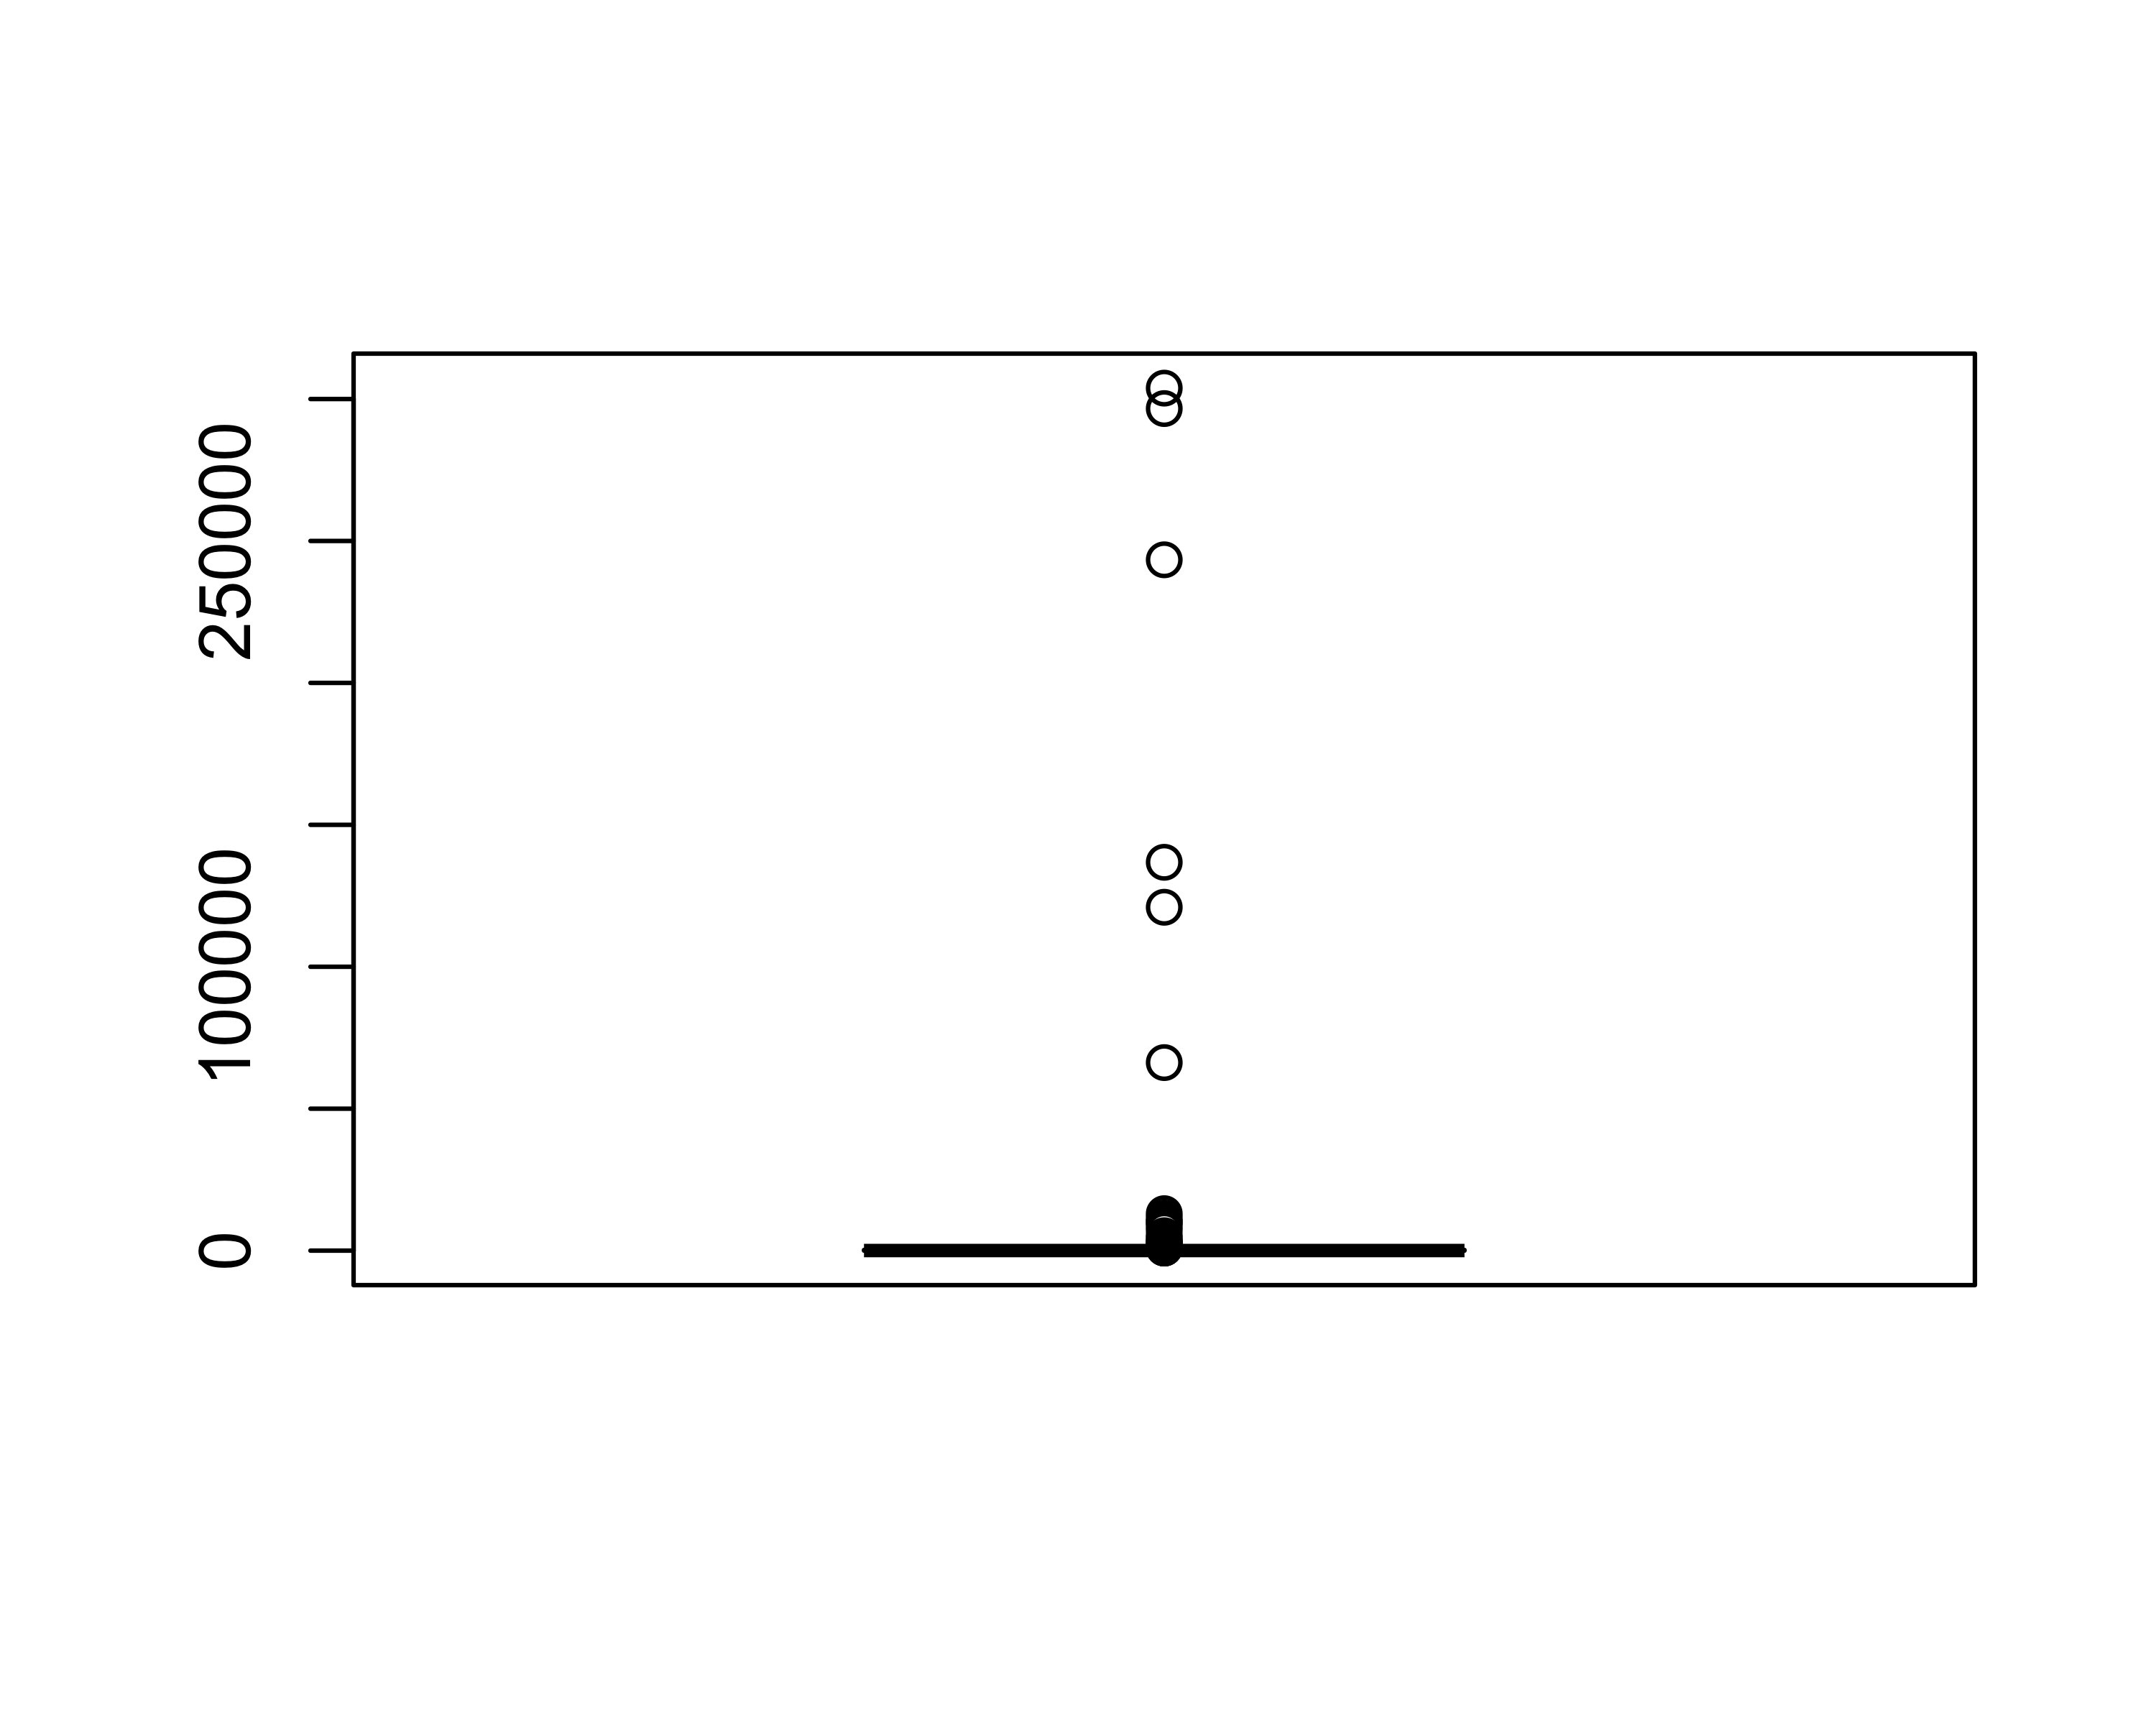

Some outlines are visible in the data. As we discussed, the insanely high burial time indicate that the body was found long after the incidence due to weather condition or some other reason. The inter-quartile range of burial time is

## [1] 207.5

## [1] 162

## [1] 41

There are 162 observation where Burial time is available among them 41 is above the inter-quartile range. Replacing them by the inter-quartile range makes the burial time a bimodal and analysis of a bimodal variable is not straight forward.

We log transform burial time and see the boxplot

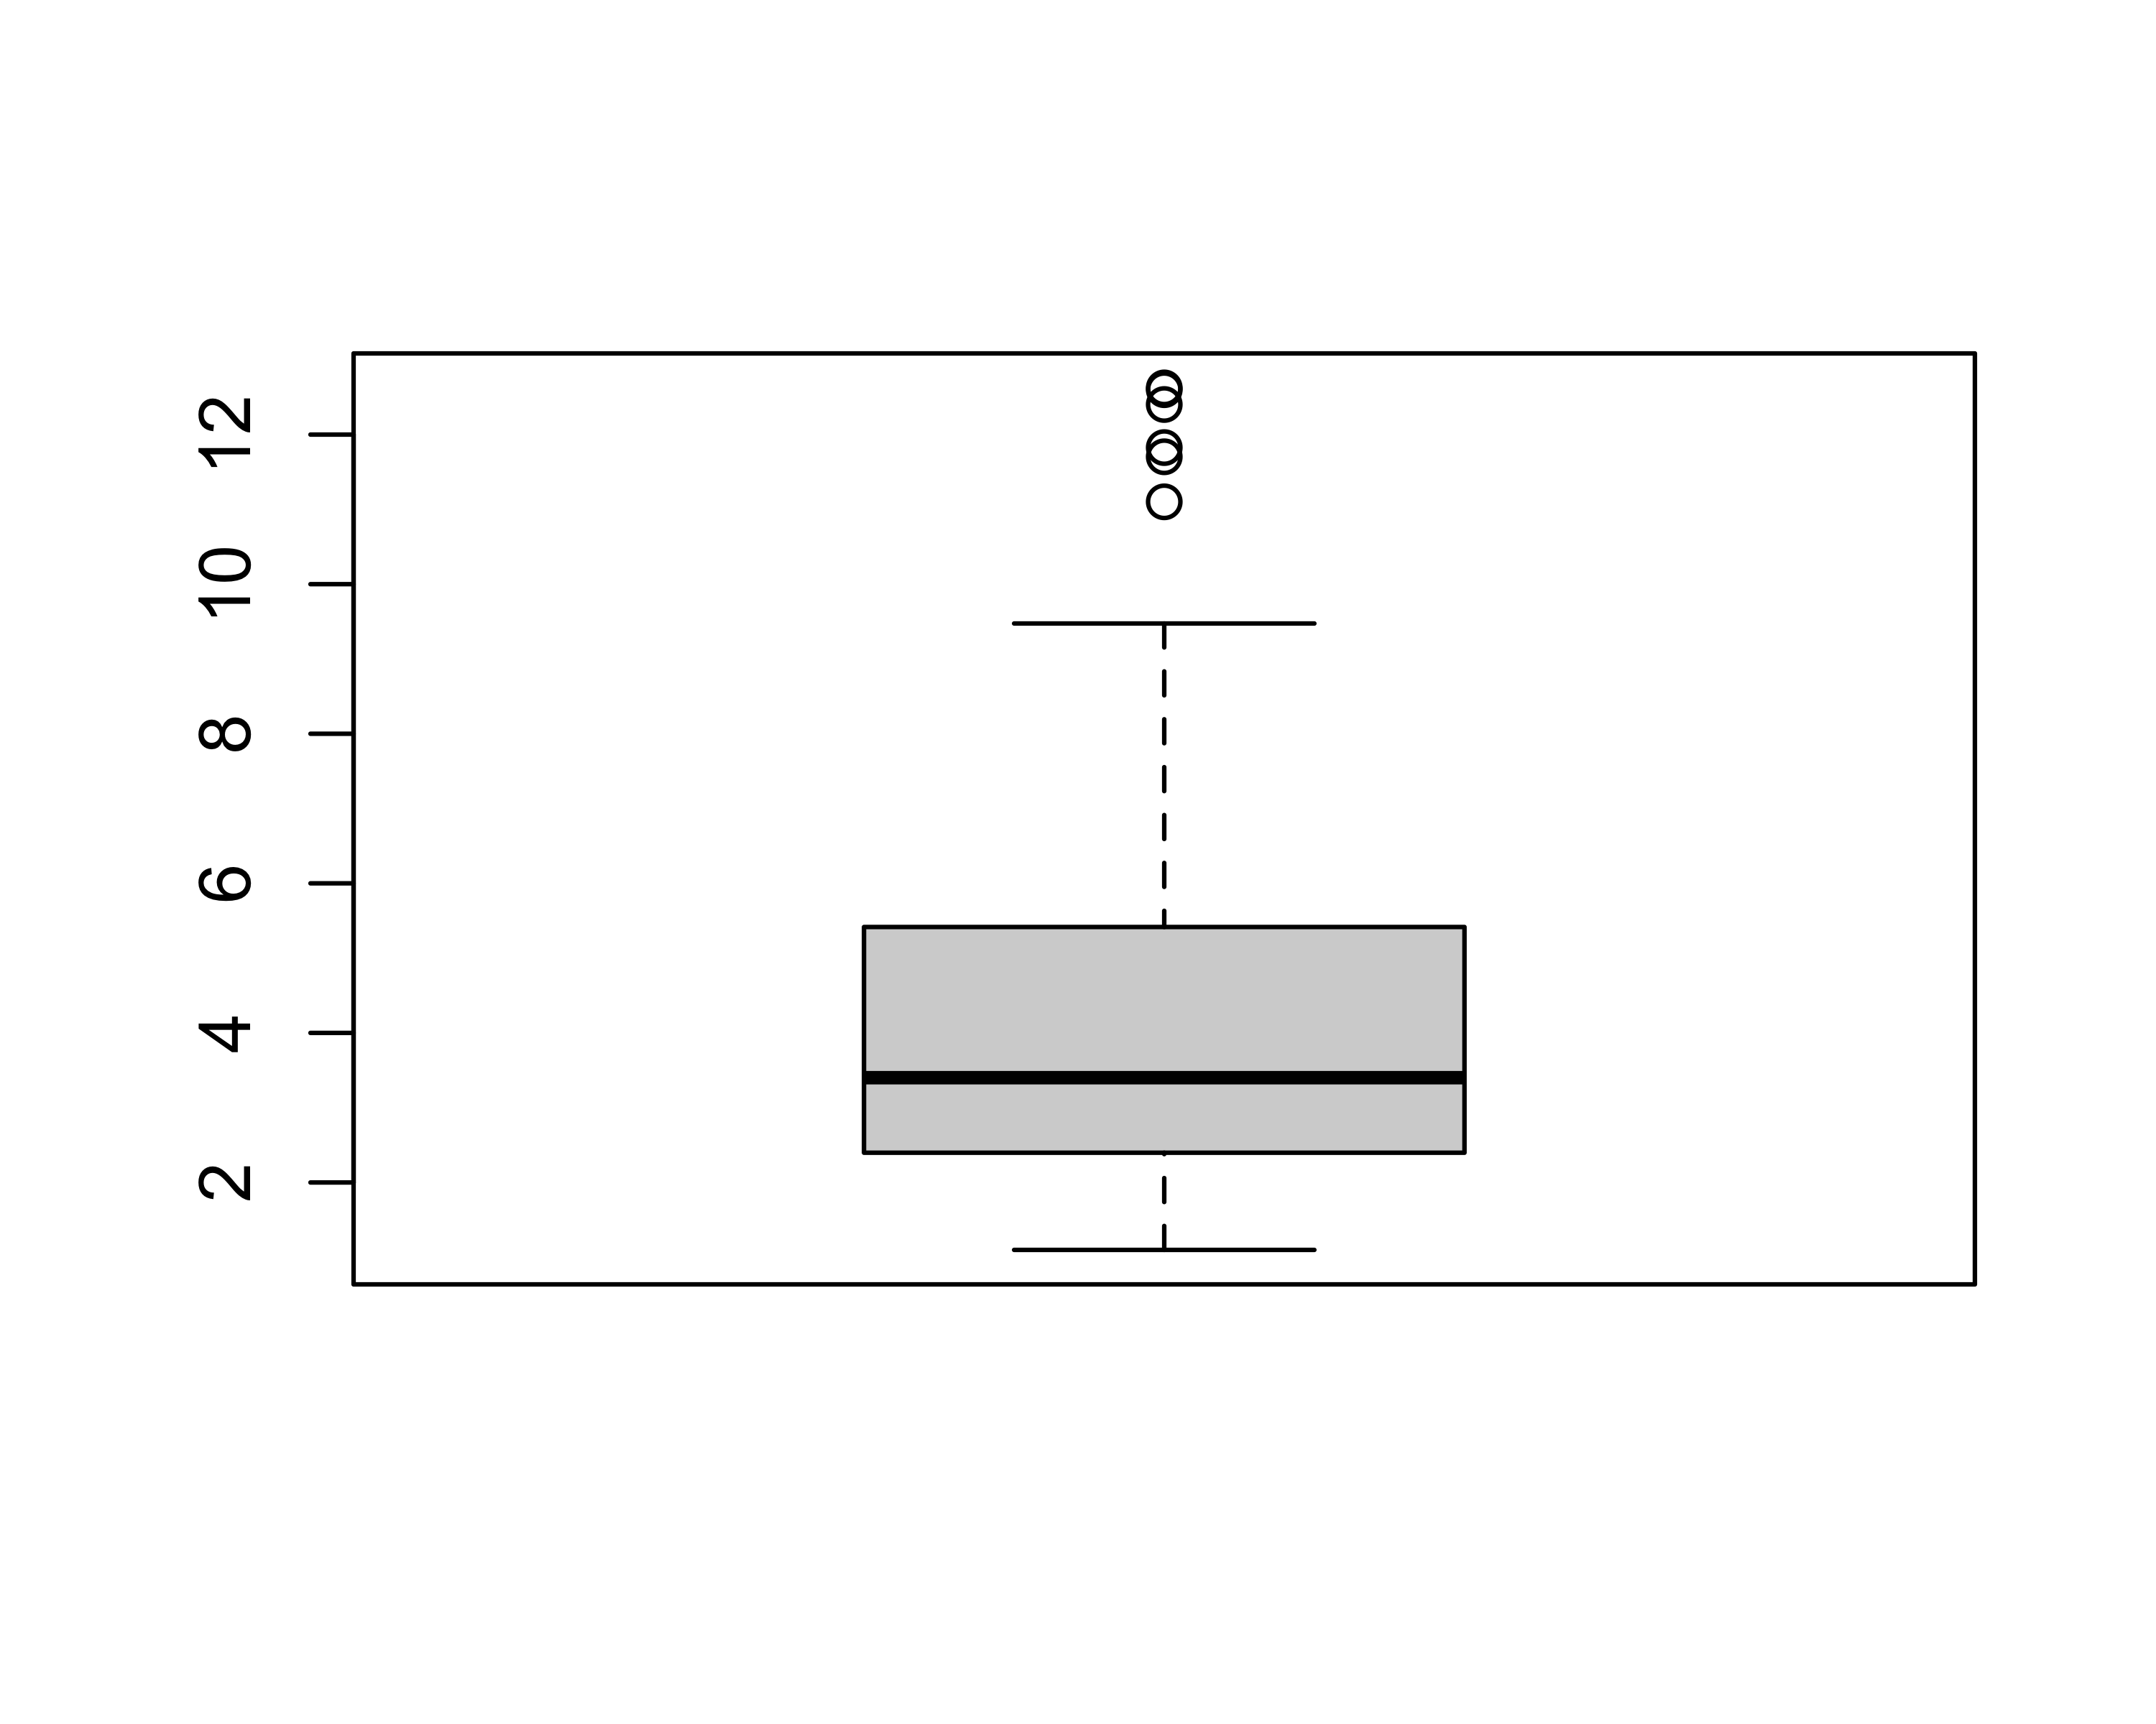 We see only a few outliers here.

## [1] 6

Removing 6 observations. There are 19 more observations that has burial time 0. I don’t understand this and removed them from further analysis as well.

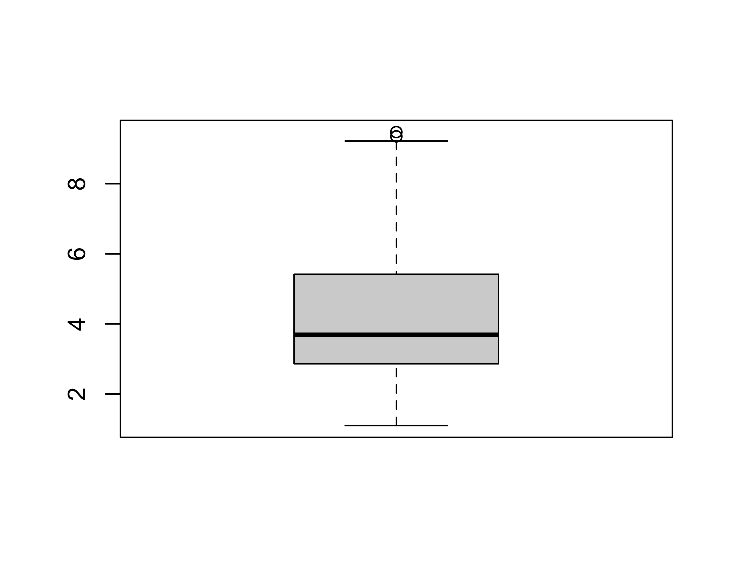

### Is burial time significantly different among tourer groups?

## Df Sum Sq Mean Sq F value Pr(>F)   
## Tourer 2 26.8 13.405 3.24 0.0422 *  
## Residuals 134 554.4 4.137   
## ---  
## Signif. codes: 0 '***' 0.001 '**' 0.01 '*' 0.05 '.' 0.1 ' ' 1  
## 43 observations deleted due to missingness

Only a slide evidence (F = 3.24, p-value = 0.042) that the burial time is related to the tourer group.

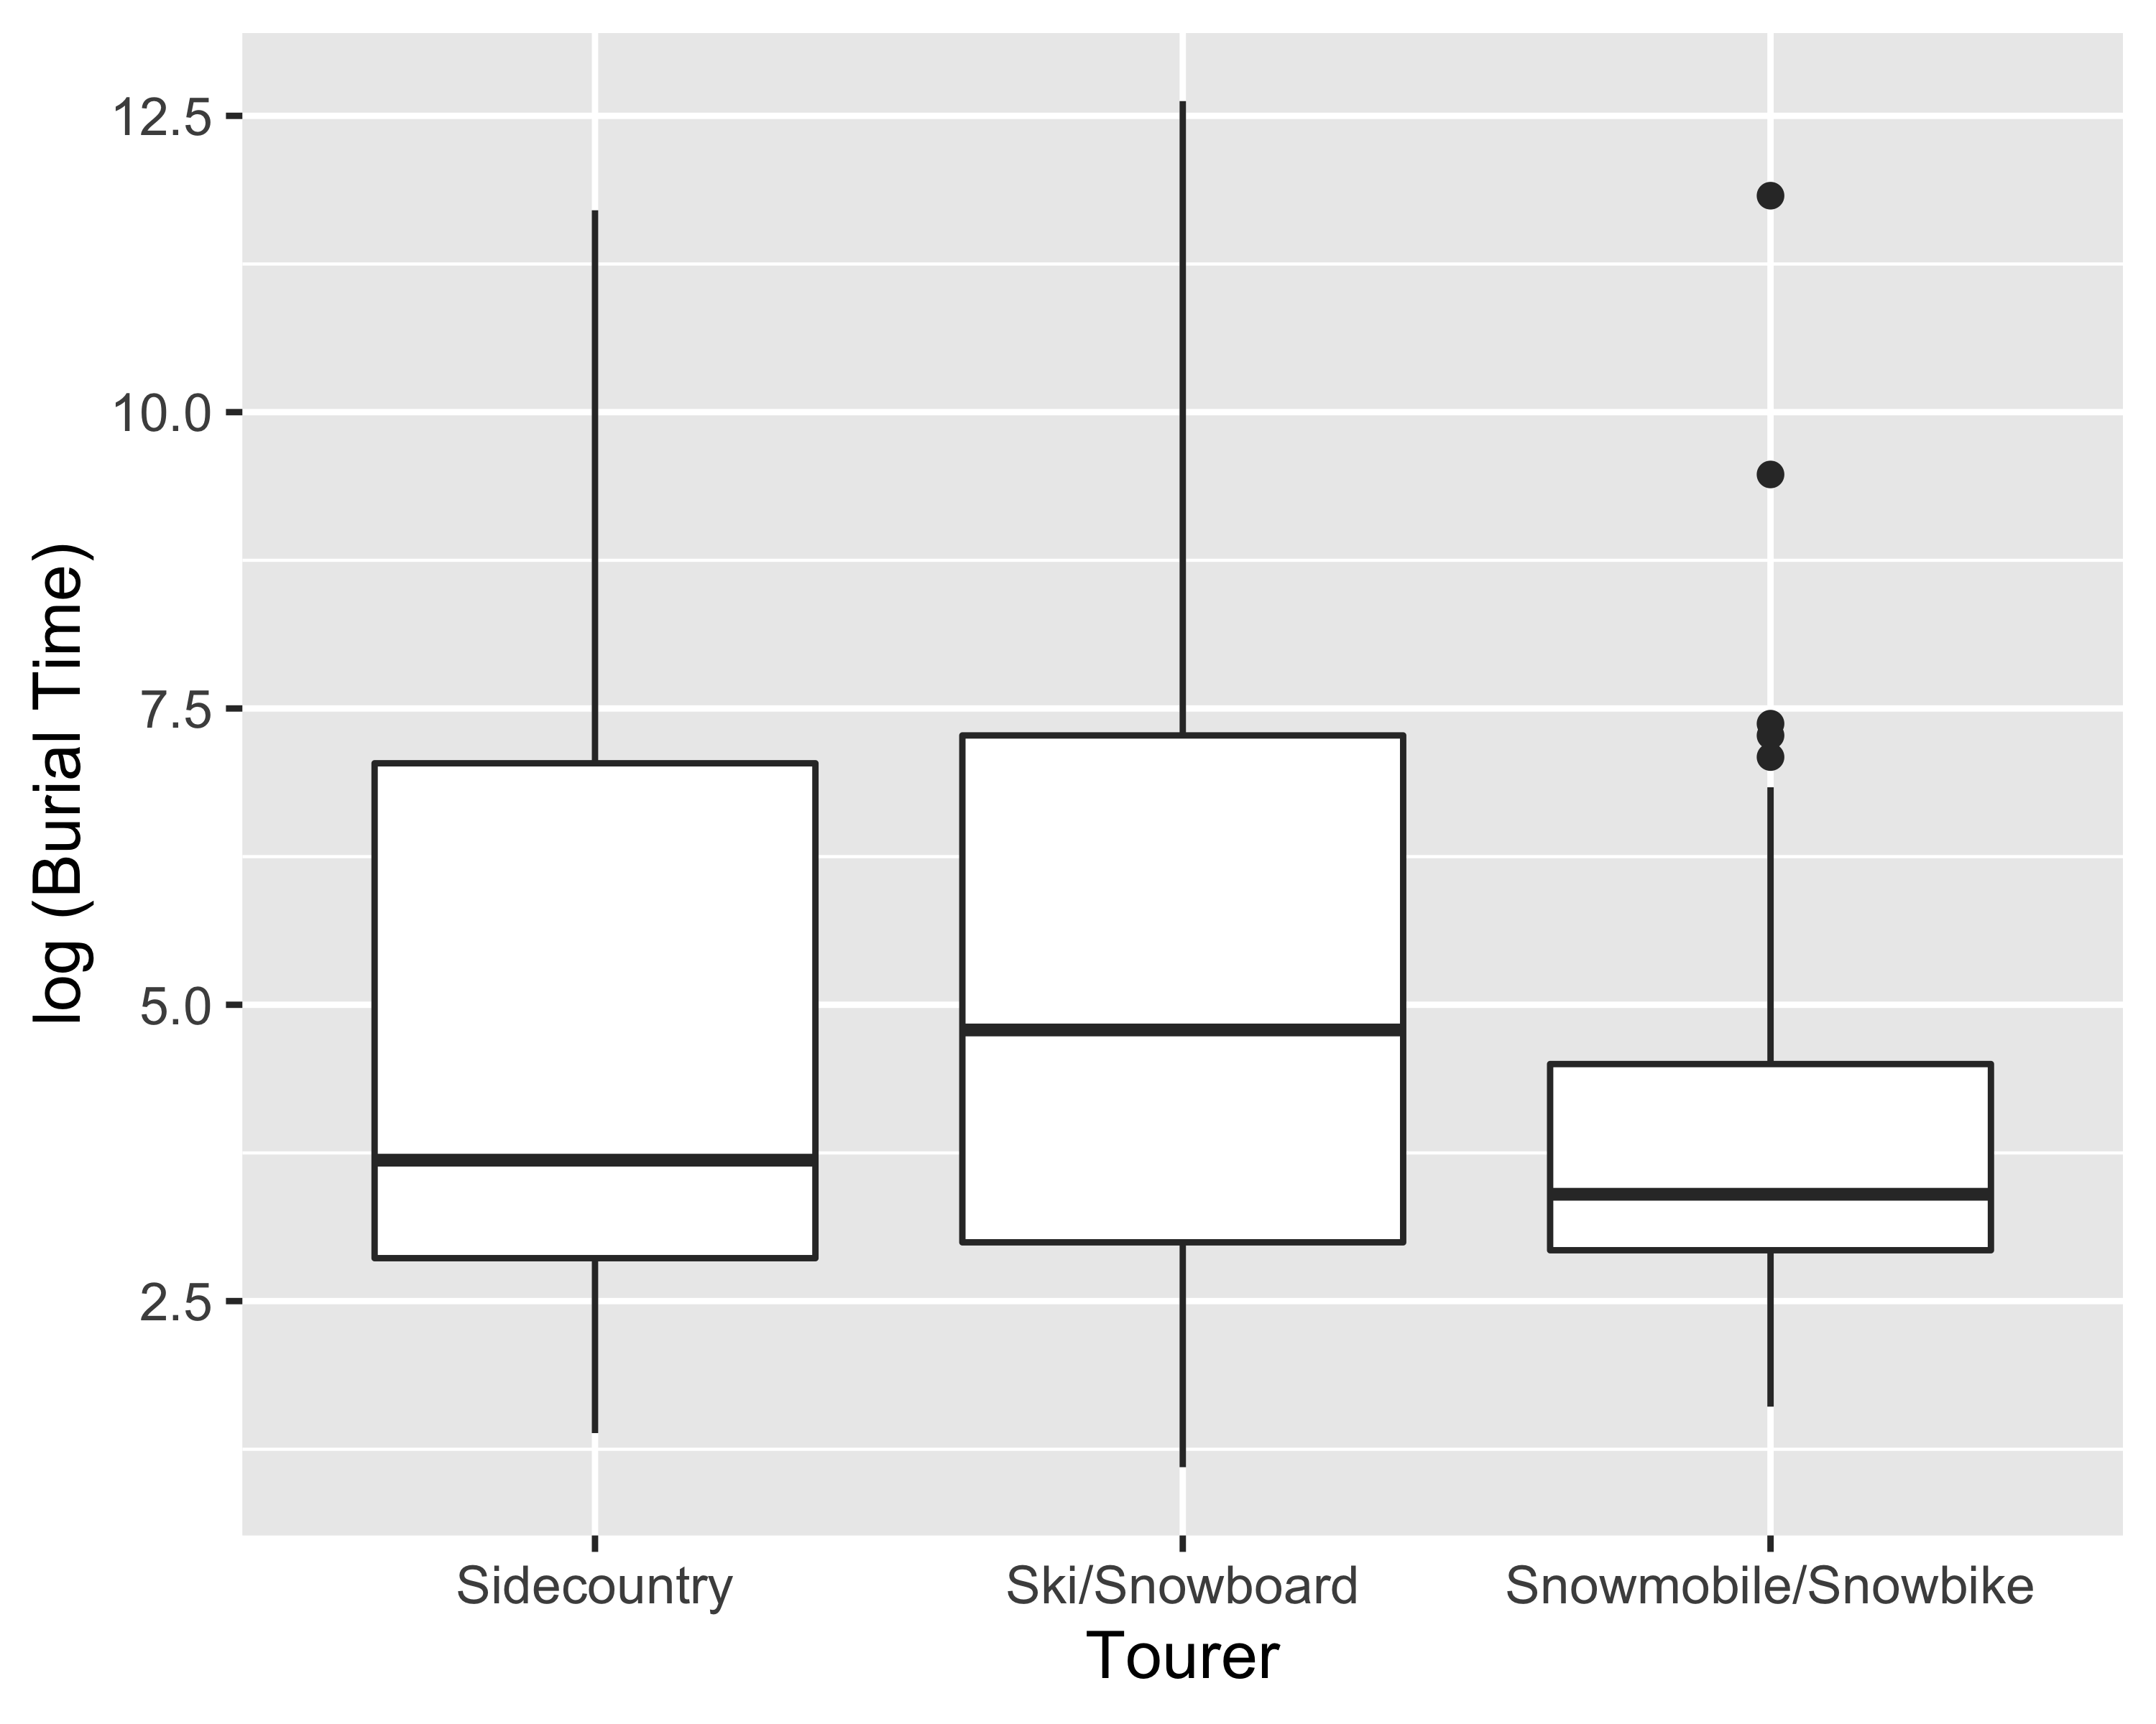 The boxplot also confirms the ANOVA result.

## Looking at burial time against other variables



## TableGrob (4 x 4) "arrange": 14 grobs  
## z cells name grob  
## Tourer 1 (1-1,1-1) arrange gtable[layout]  
## Gender 2 (1-1,2-2) arrange gtable[layout]  
## Total_in_party_cat_bin 3 (1-1,3-3) arrange gtable[layout]  
## Preparedness1 4 (1-1,4-4) arrange gtable[layout]  
## Preparedness2 5 (2-2,1-1) arrange gtable[layout]  
## Preparedness3 6 (2-2,2-2) arrange gtable[layout]  
## Preparedness4 7 (2-2,3-3) arrange gtable[layout]  
## Avalanche_Type 8 (2-2,4-4) arrange gtable[layout]  
## Avalanche_Size_RP 9 (3-3,1-1) arrange gtable[layout]  
## Avalanche_Size_DF 10 (3-3,2-2) arrange gtable[layout]  
## Avalanche_Forcast 11 (3-3,3-3) arrange gtable[layout]  
## Elevation 12 (3-3,4-4) arrange gtable[layout]  
## Angle 13 (4-4,1-1) arrange gtable[layout]  
## Aspect 14 (4-4,2-2) arrange gtable[layout]



### Observations:

1. Burial time does not differ based on Tourer group
2. Burial time looks different for male and female
3. Burial time for single person looks higher than group
4. Burial time decrease significantly with increase of preparedness
5. Can’t comment on Avalanche properties without further investigation
6. Does not looks like Elevation and Angle are associated with burial time.

## Additional analysis based on comments on Jan 7th

## Analysis 1: Burial time $<$ 15 vs $≥15$

Comment: The only other metric for burial time that would be helpful is the number of burials that were 15 min or less (suggesting that the group was more prepared). So if there is a way to say a certain group had a statistical difference in the percentage that were 15 min or less, not including the people who weren’t buried.

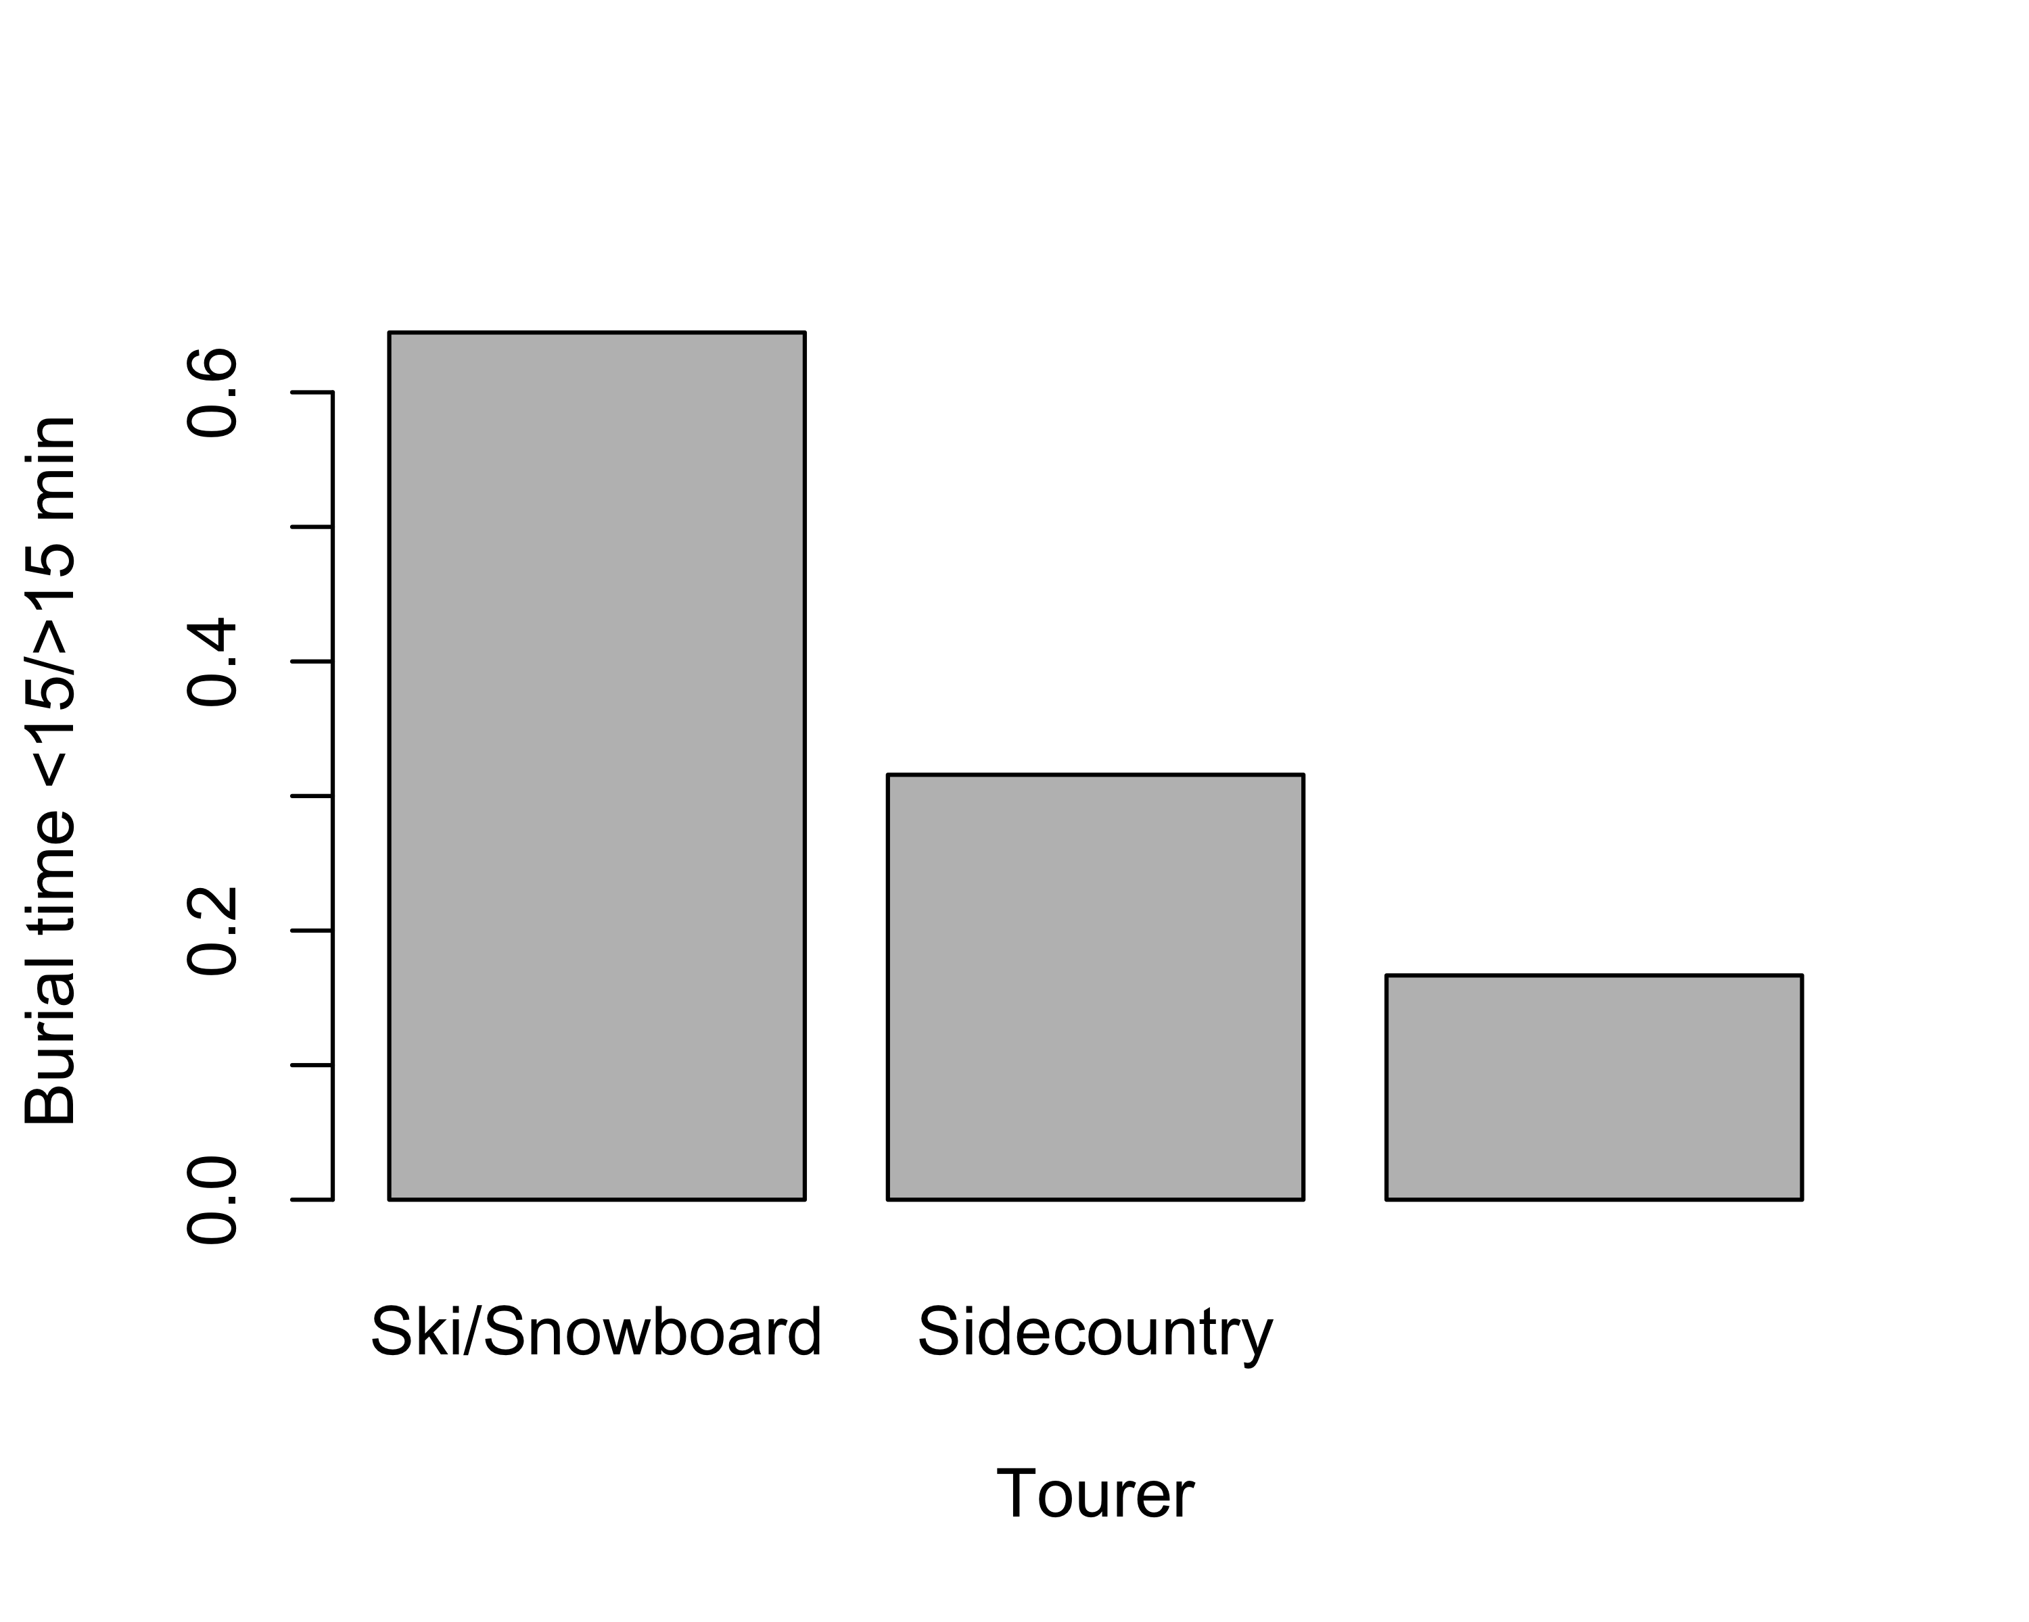quartz_off_screen 2

##   
## Pearson's Chi-squared test  
##   
## data: table(dat$Burial_time < 15, dat$Tourer)  
## X-squared = 10.817, df = 2, p-value = 0.004479

### Analysis 2:

Comment: The last few things I was hoping for are some of those variables looked at individually, rather than in conjunction with burial time. For example, for avalanche forecast, is there a difference in the distribution of each forecast type among the 3 groups or are there significantly more of one forecast than another. For the following variables, I am just looking at them independently. Here would be the question for each:

#### 1. total in party: was the average group size for each of the three groups significantly different? Could we do one graph showing that distribution?

##   
## One-way analysis of means (not assuming equal variances)  
##   
## data: Total_in_party and Tourer  
## F = 1.9479, num df = 2.000, denom df = 74.548, p-value = 0.1498

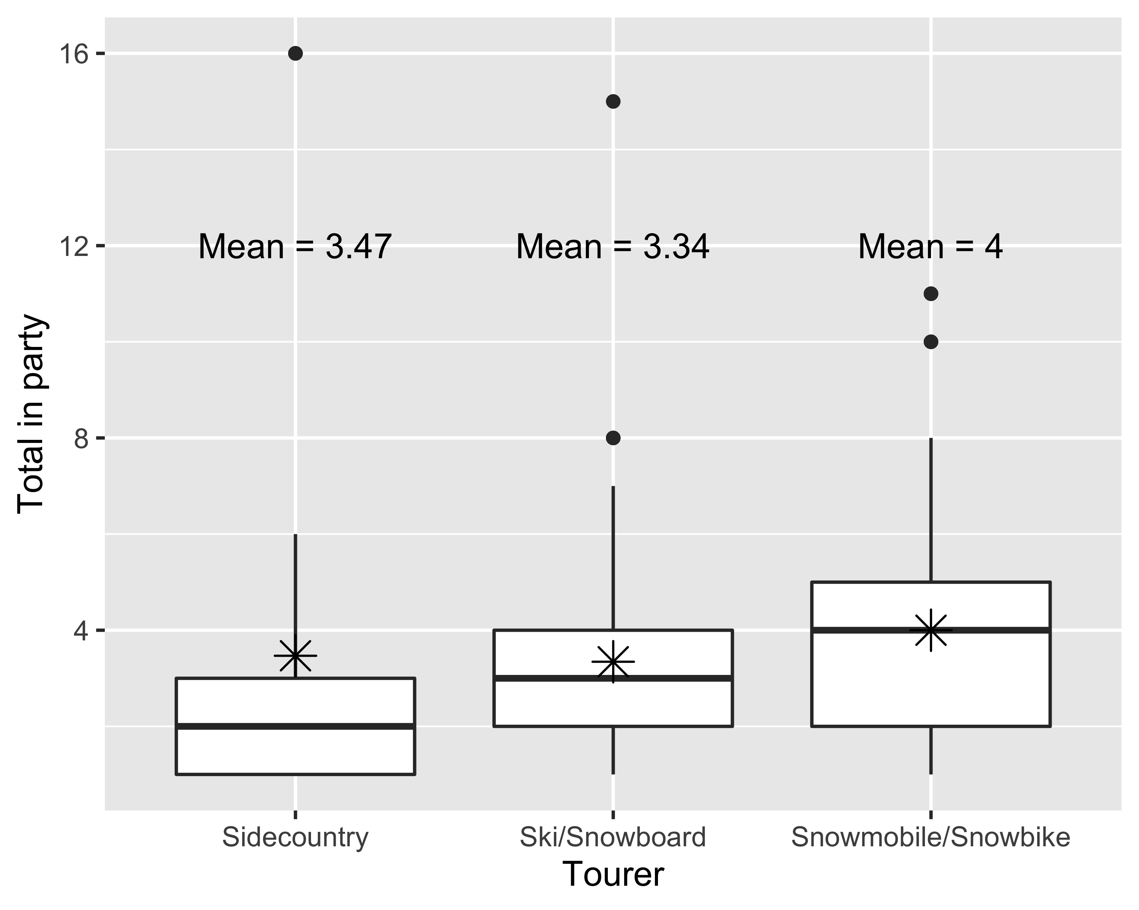

#### 2. avalanche type: Were there more of a certain types in one group compared to another?

Pearson's Chi-squared test

data: table(dat $Avalanche_{T}ype,dat$ Tourer) X-squared = 15.577, df = 12, p-value = 0.2114

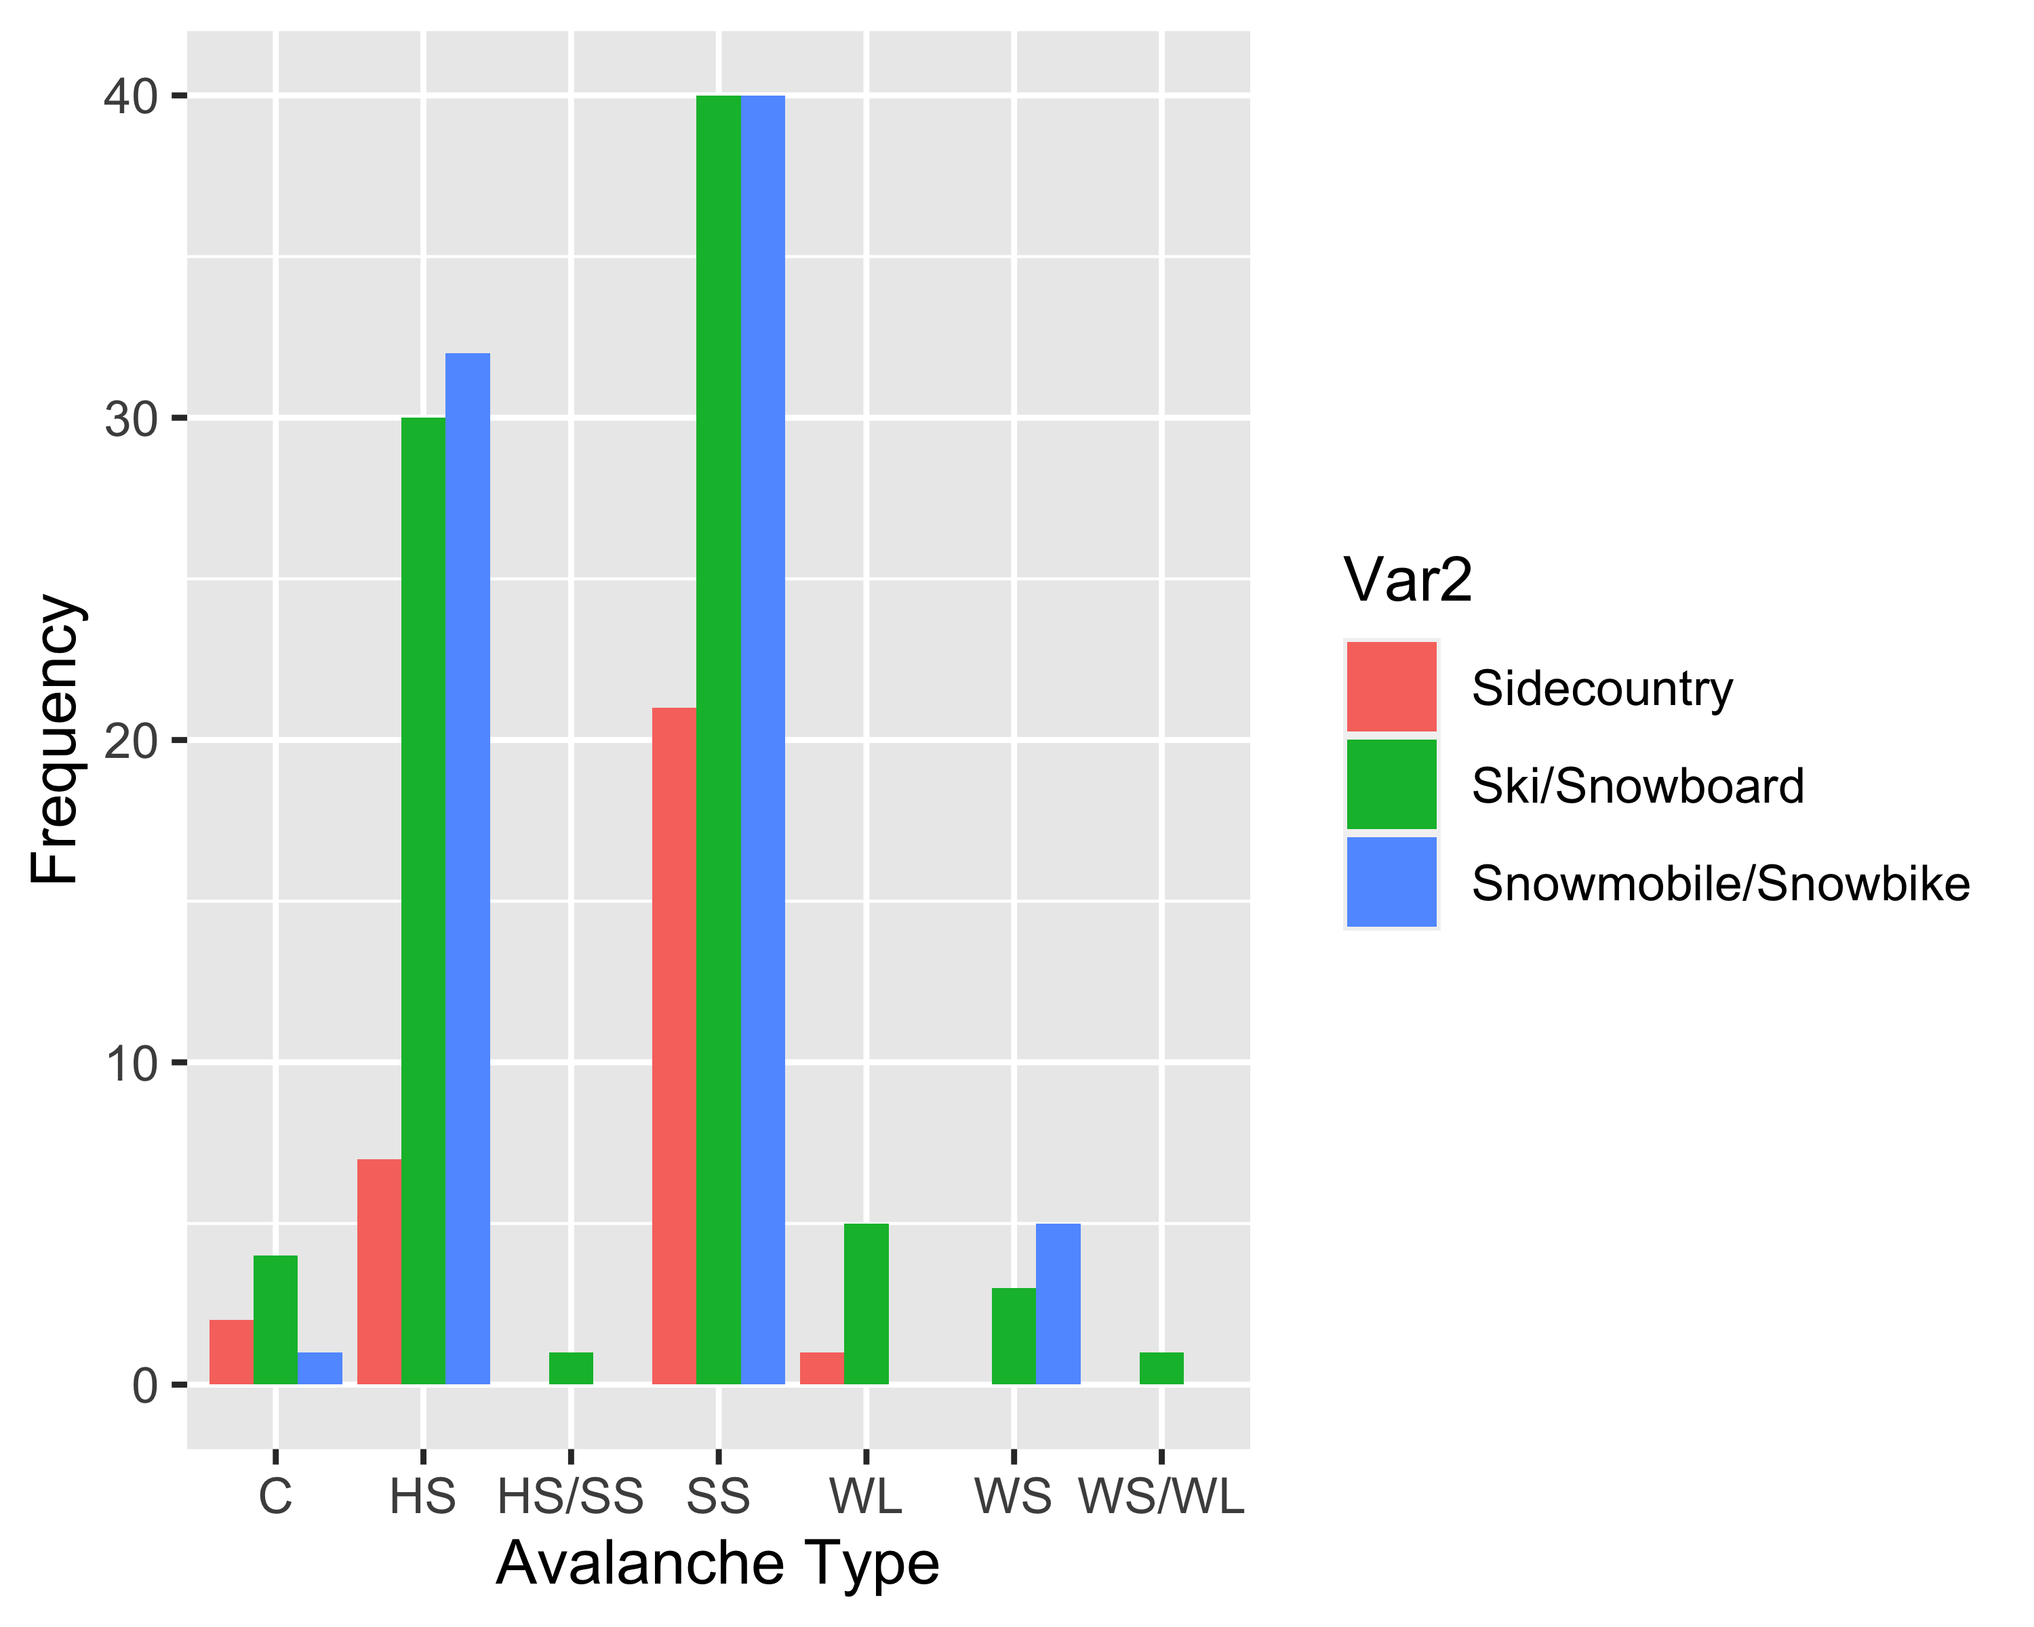

##   
## Pearson's Chi-squared test  
##   
## data: contin_table[c(2, 4), ]  
## X-squared = 3.4149, df = 2, p-value = 0.1813

#### 3. size (R). Is the average size and/or distribution different between the three groups?

Pearson's Chi-squared test

data: table(dat $Avalanche_{S}ize_{R}P,dat$ Tourer) X-squared = 24.273, df = 10, p-value = 0.006907

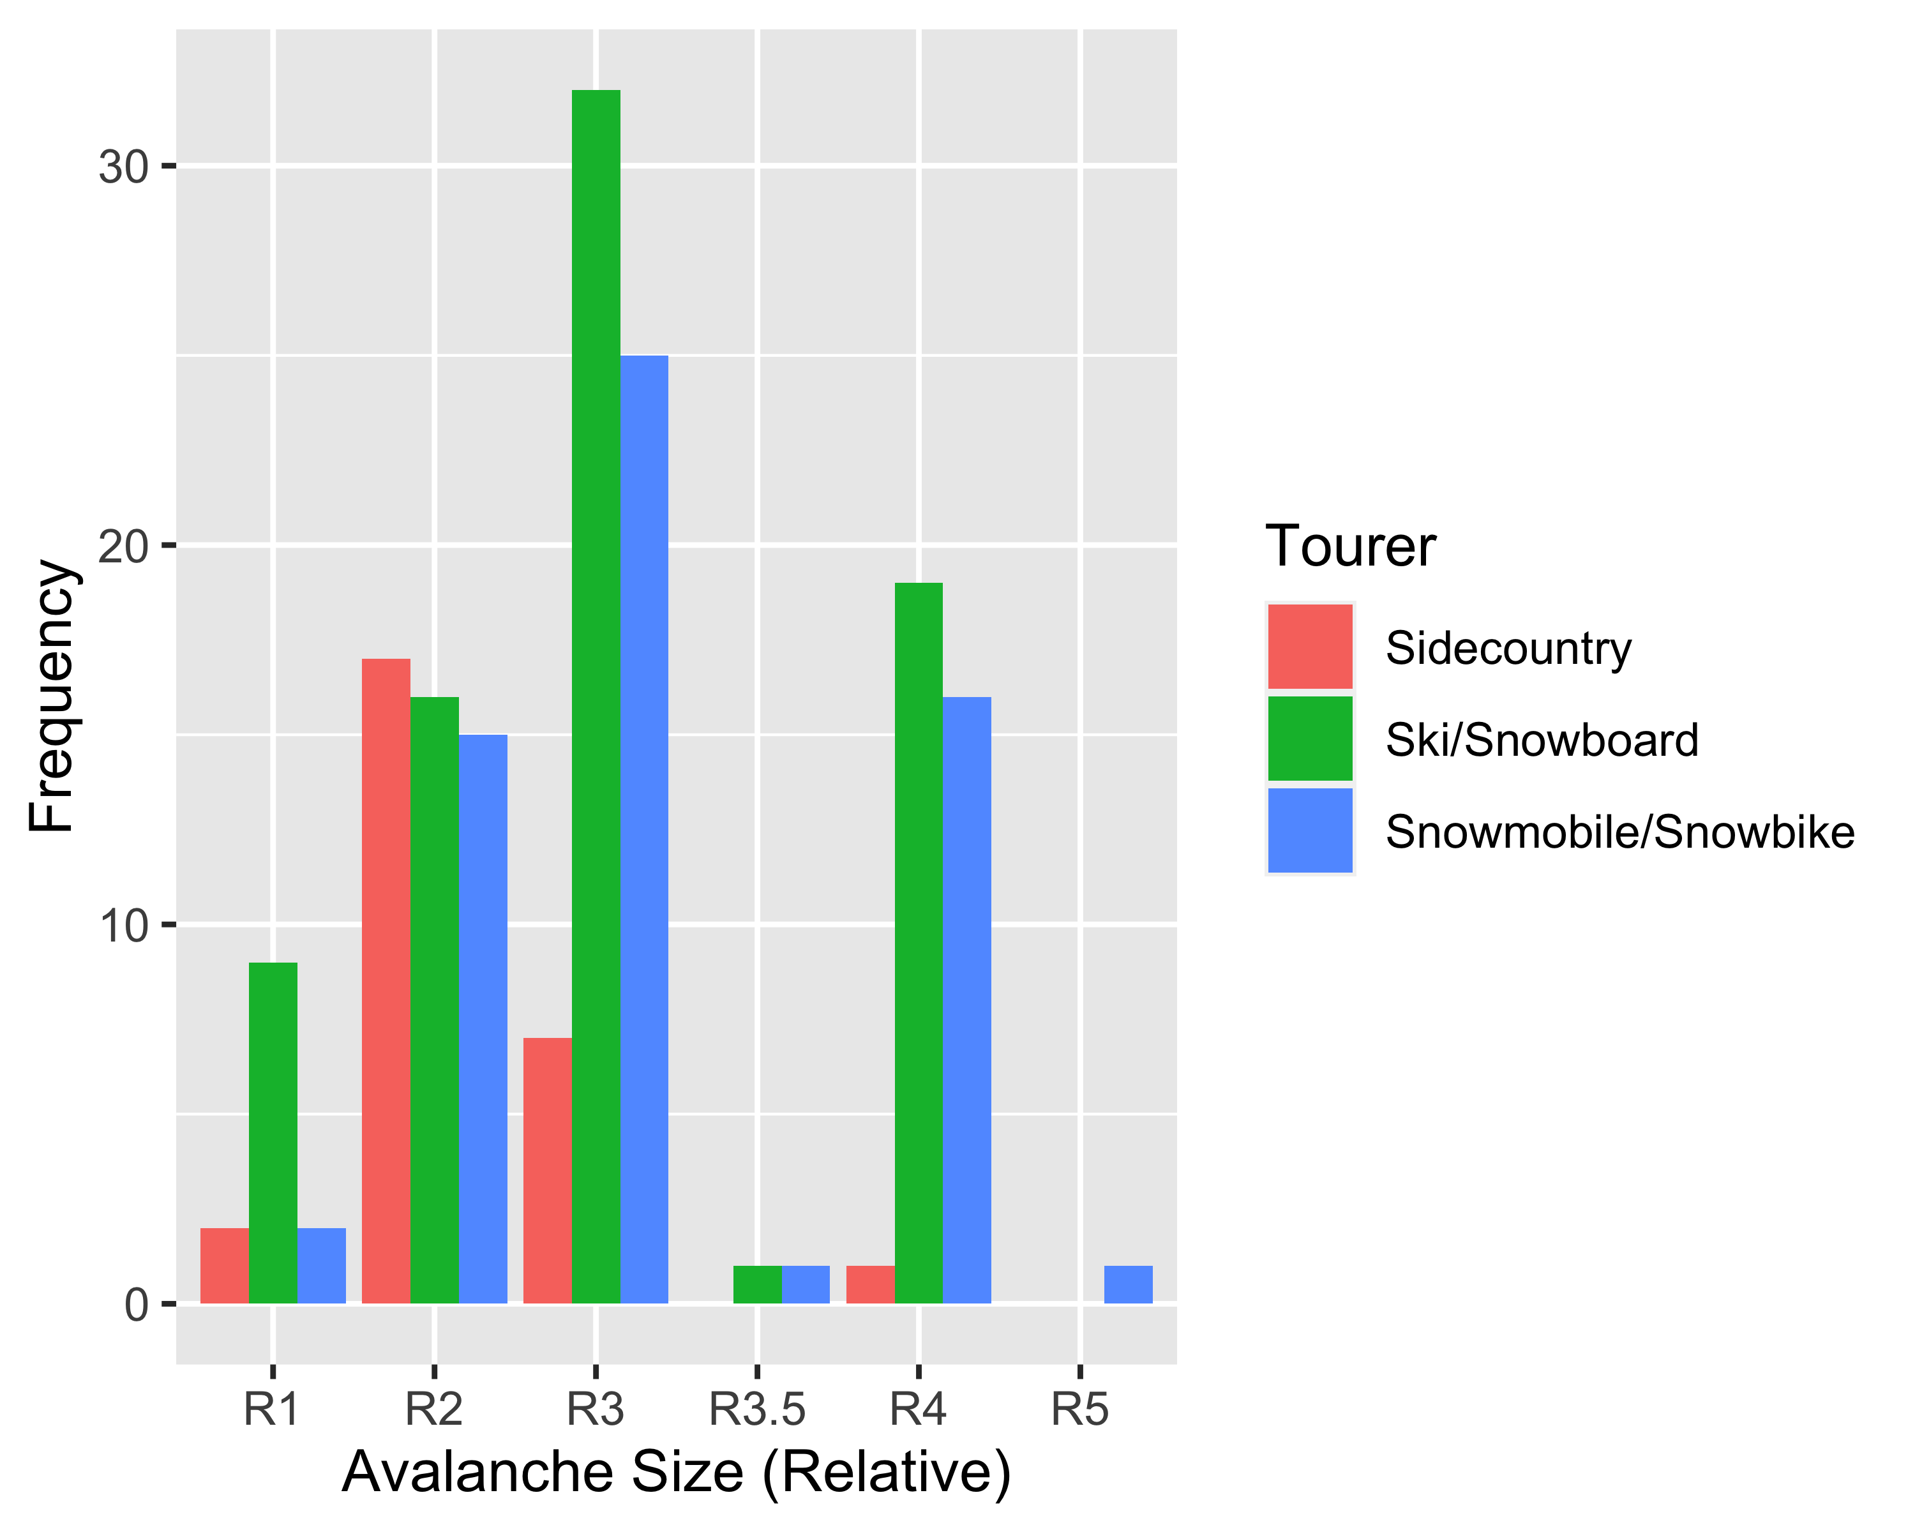

Pearson's Chi-squared test

data: table(y, x) X-squared = 22.234, df = 6, p-value = 0.001098

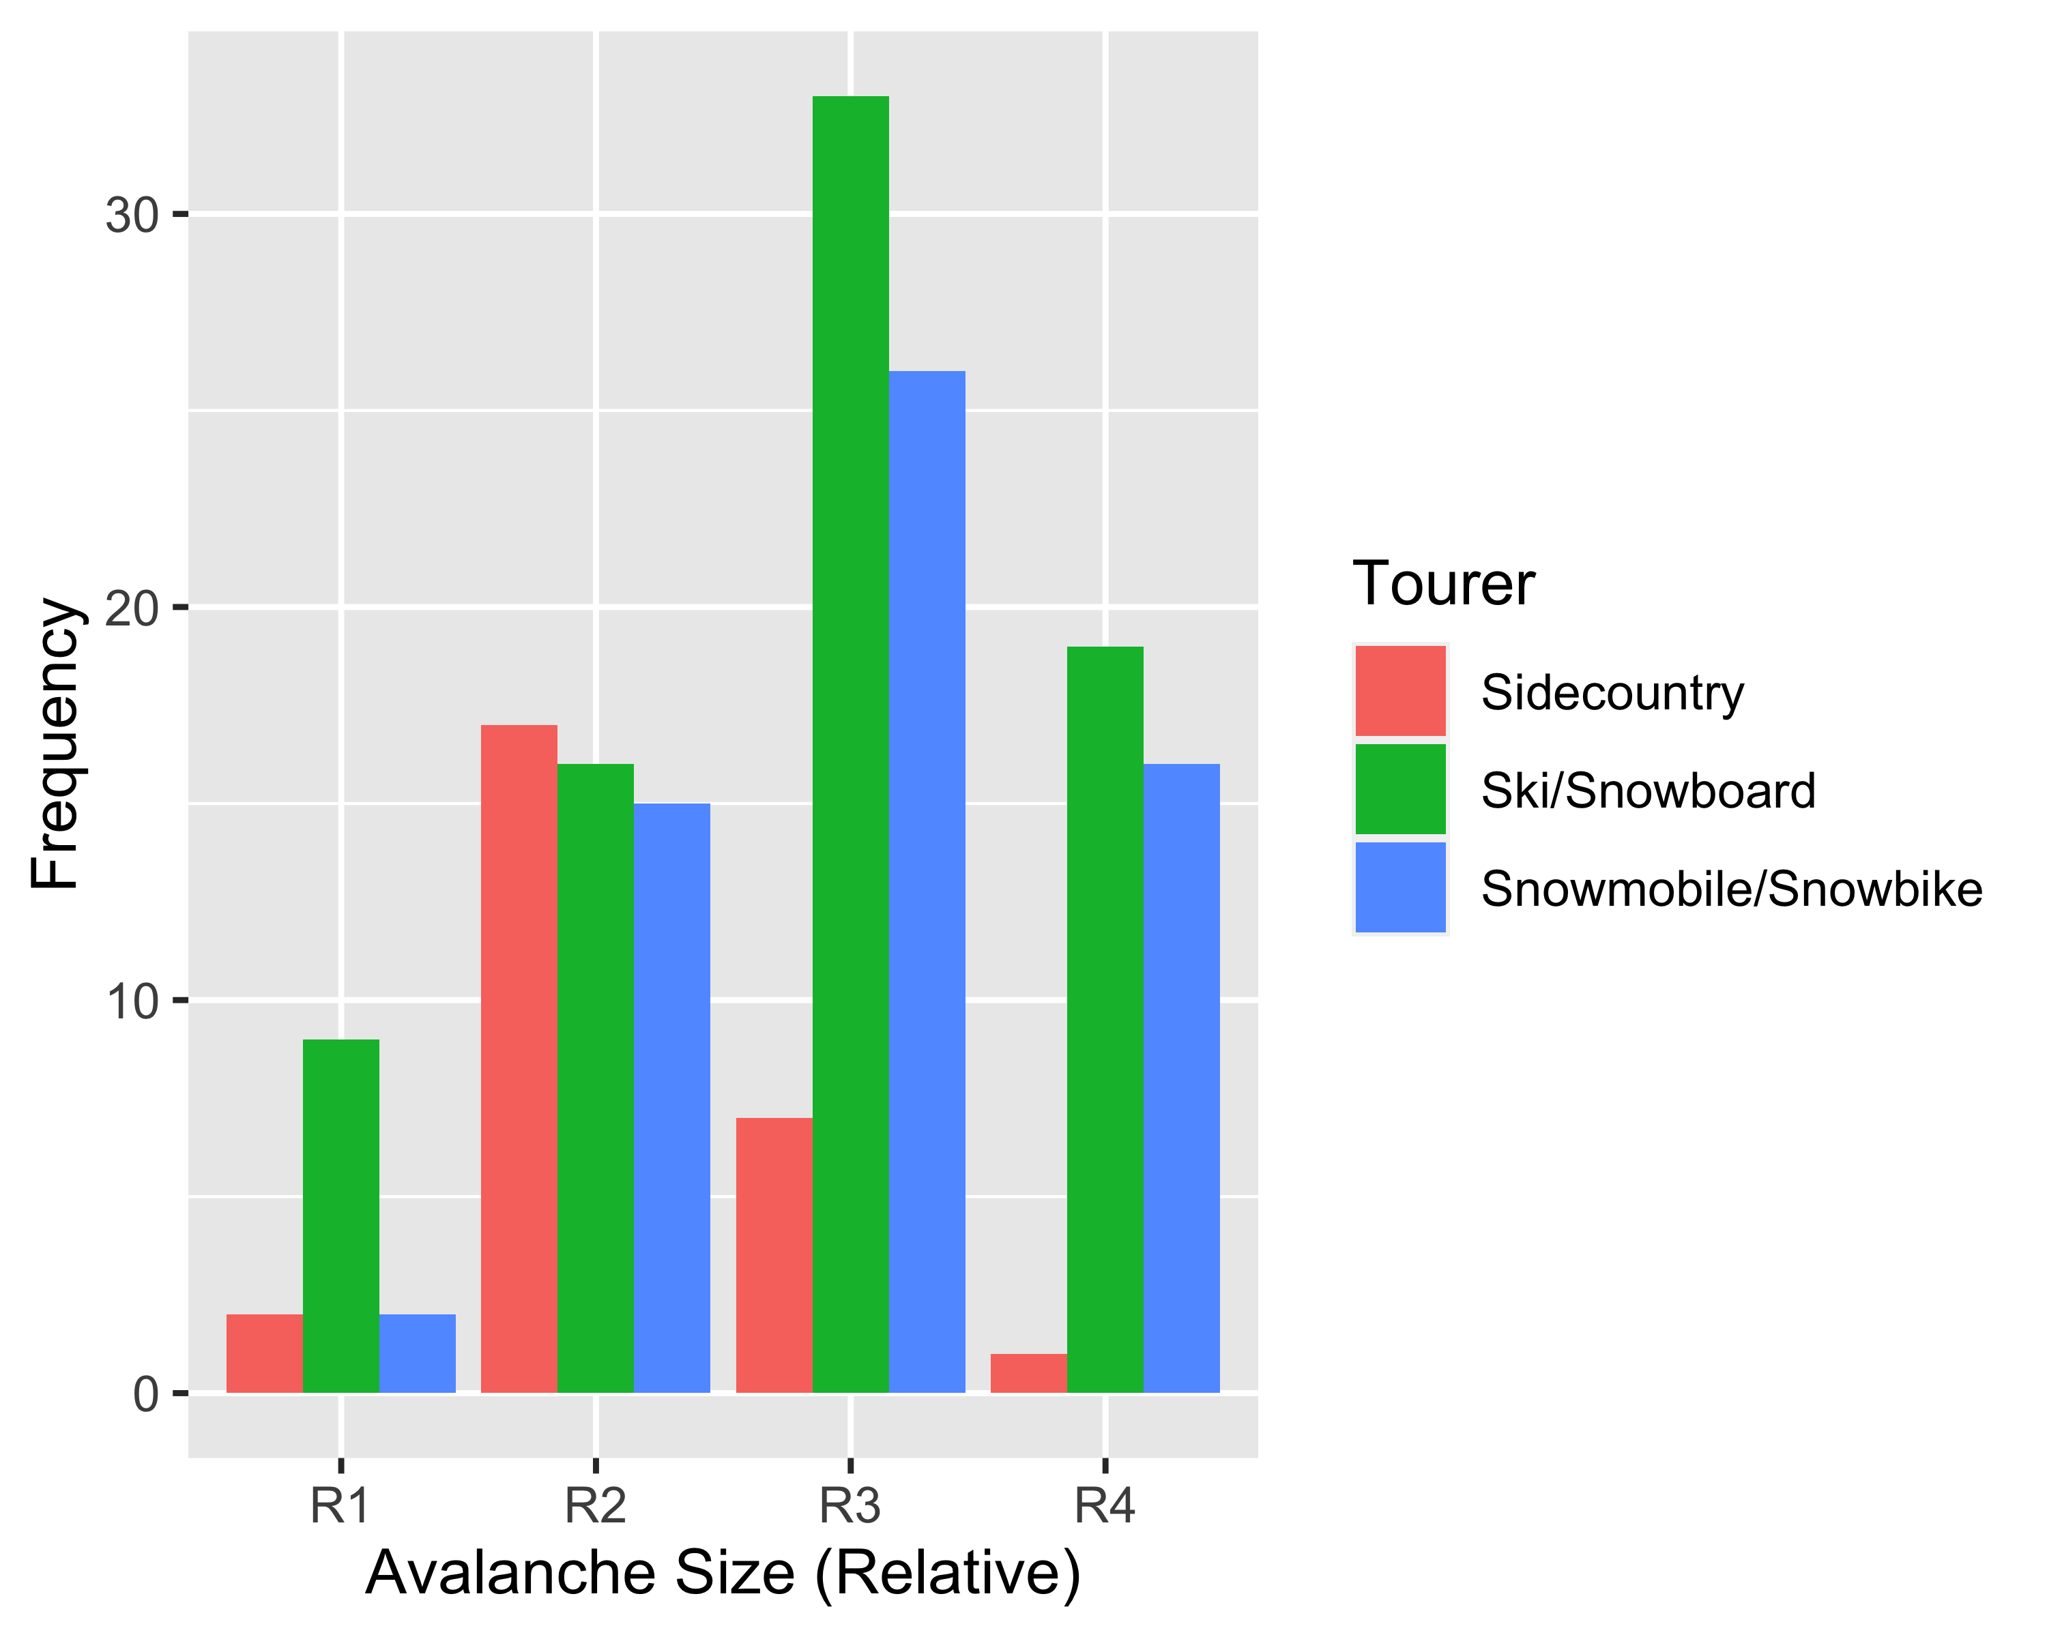

1. size (D)- you can include 2 and 2.5 in one category, 3 and 3.5 together, etc. if that is easier. Same here, is the size/distrubtion different among the groups. If we can’t find any differences just having a box plot for these two size ones would be fine to show the distribution.

* Pearson’s Chi-squared test

data: table(y, x) X-squared = 10.725, df = 6, p-value = 0.09726

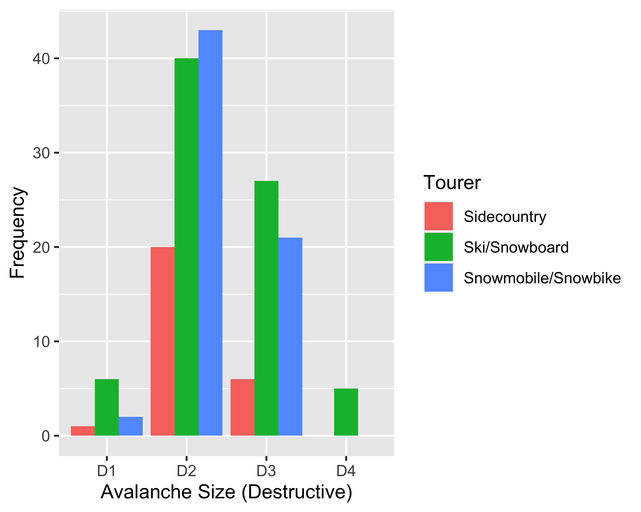

Pearson's Chi-squared test

data: table(dat $Avalanche_{S}ize_{D}F[kept],dat$ Tourer[kept]) X-squared = 24.732, df = 12, p-value = 0.01615

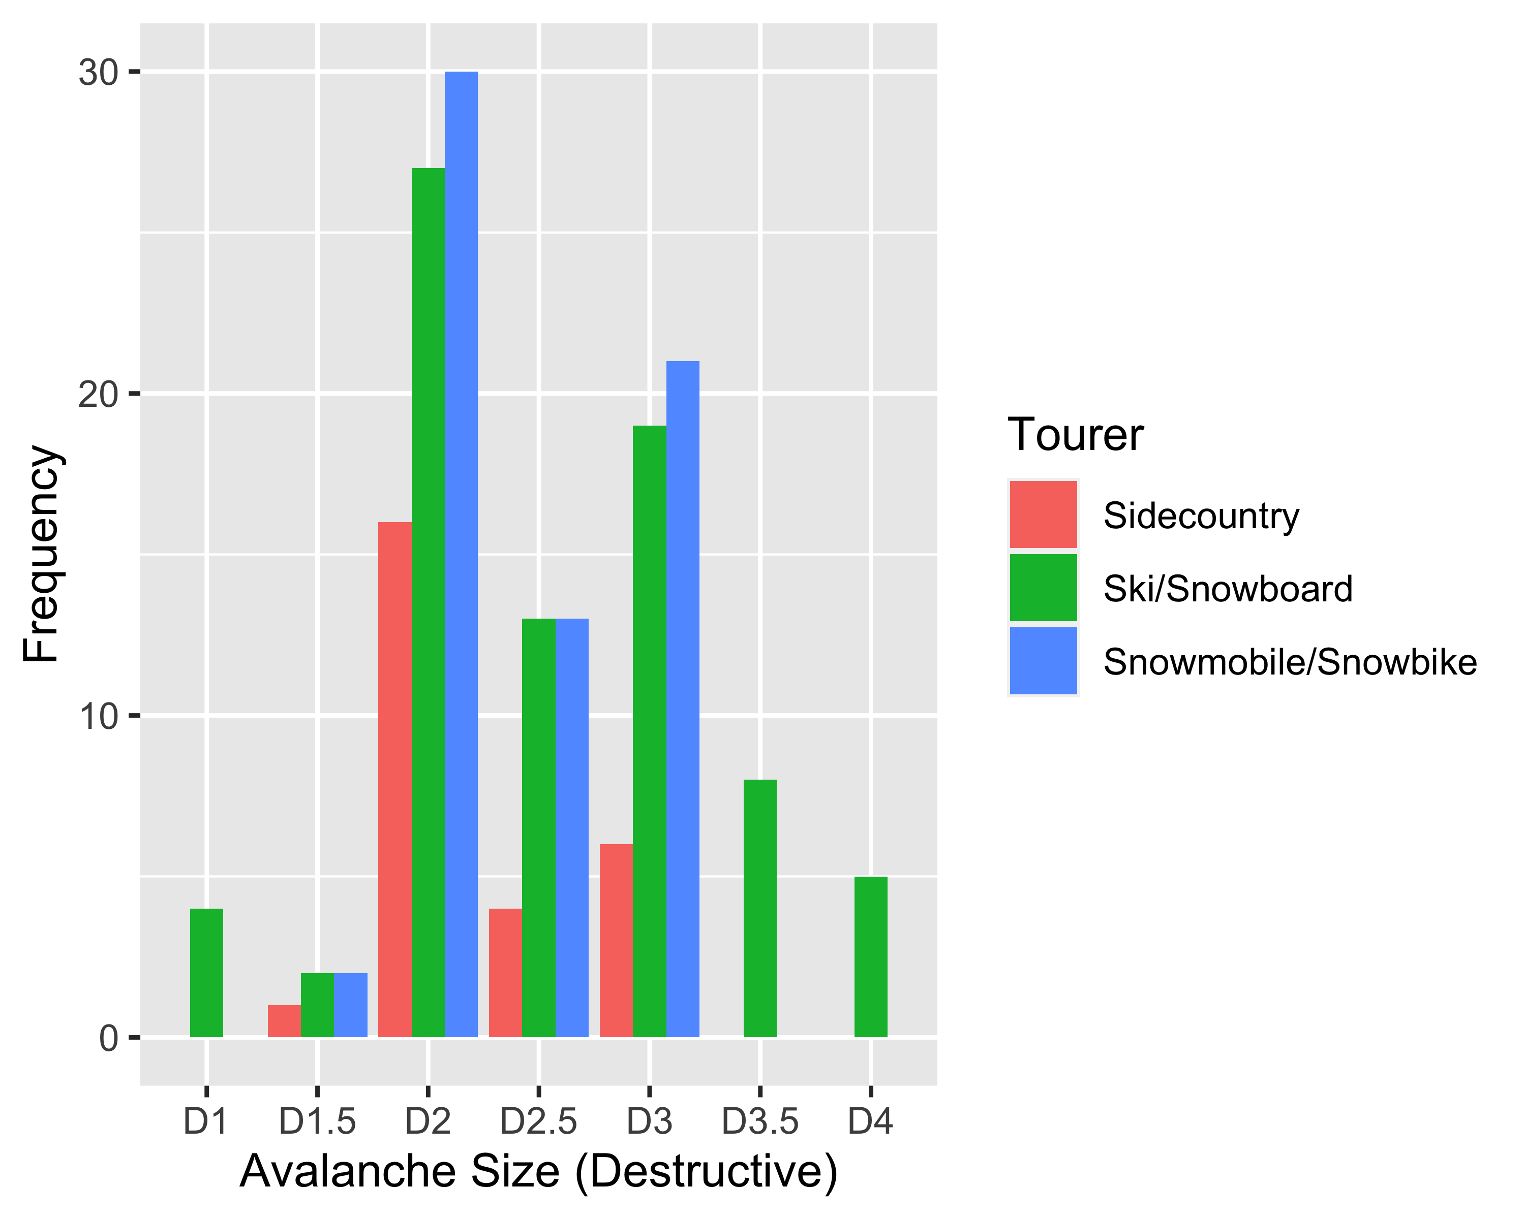

1. burial depth: are the average burial depths different among the three groups?

##   
## One-way analysis of means (not assuming equal variances)  
##   
## data: Burial_Depth and Tourer  
## F = 7.1958, num df = 2.000, denom df = 79.775, p-value = 0.001339

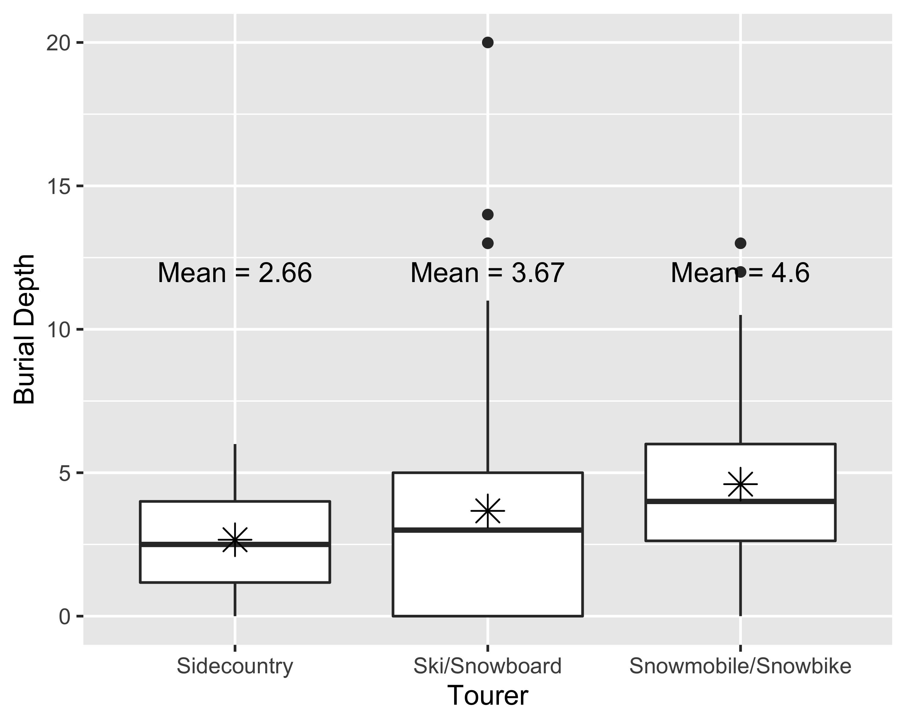

#### 6. forecast: is there a difference in distribution of the forecast or which ones are most common among the 3 groups?

Pearson's Chi-squared test

data: table(dat $Avalanche_{F}orcast,dat$ Tourer) X-squared = 11.911, df = 8, p-value = 0.1552

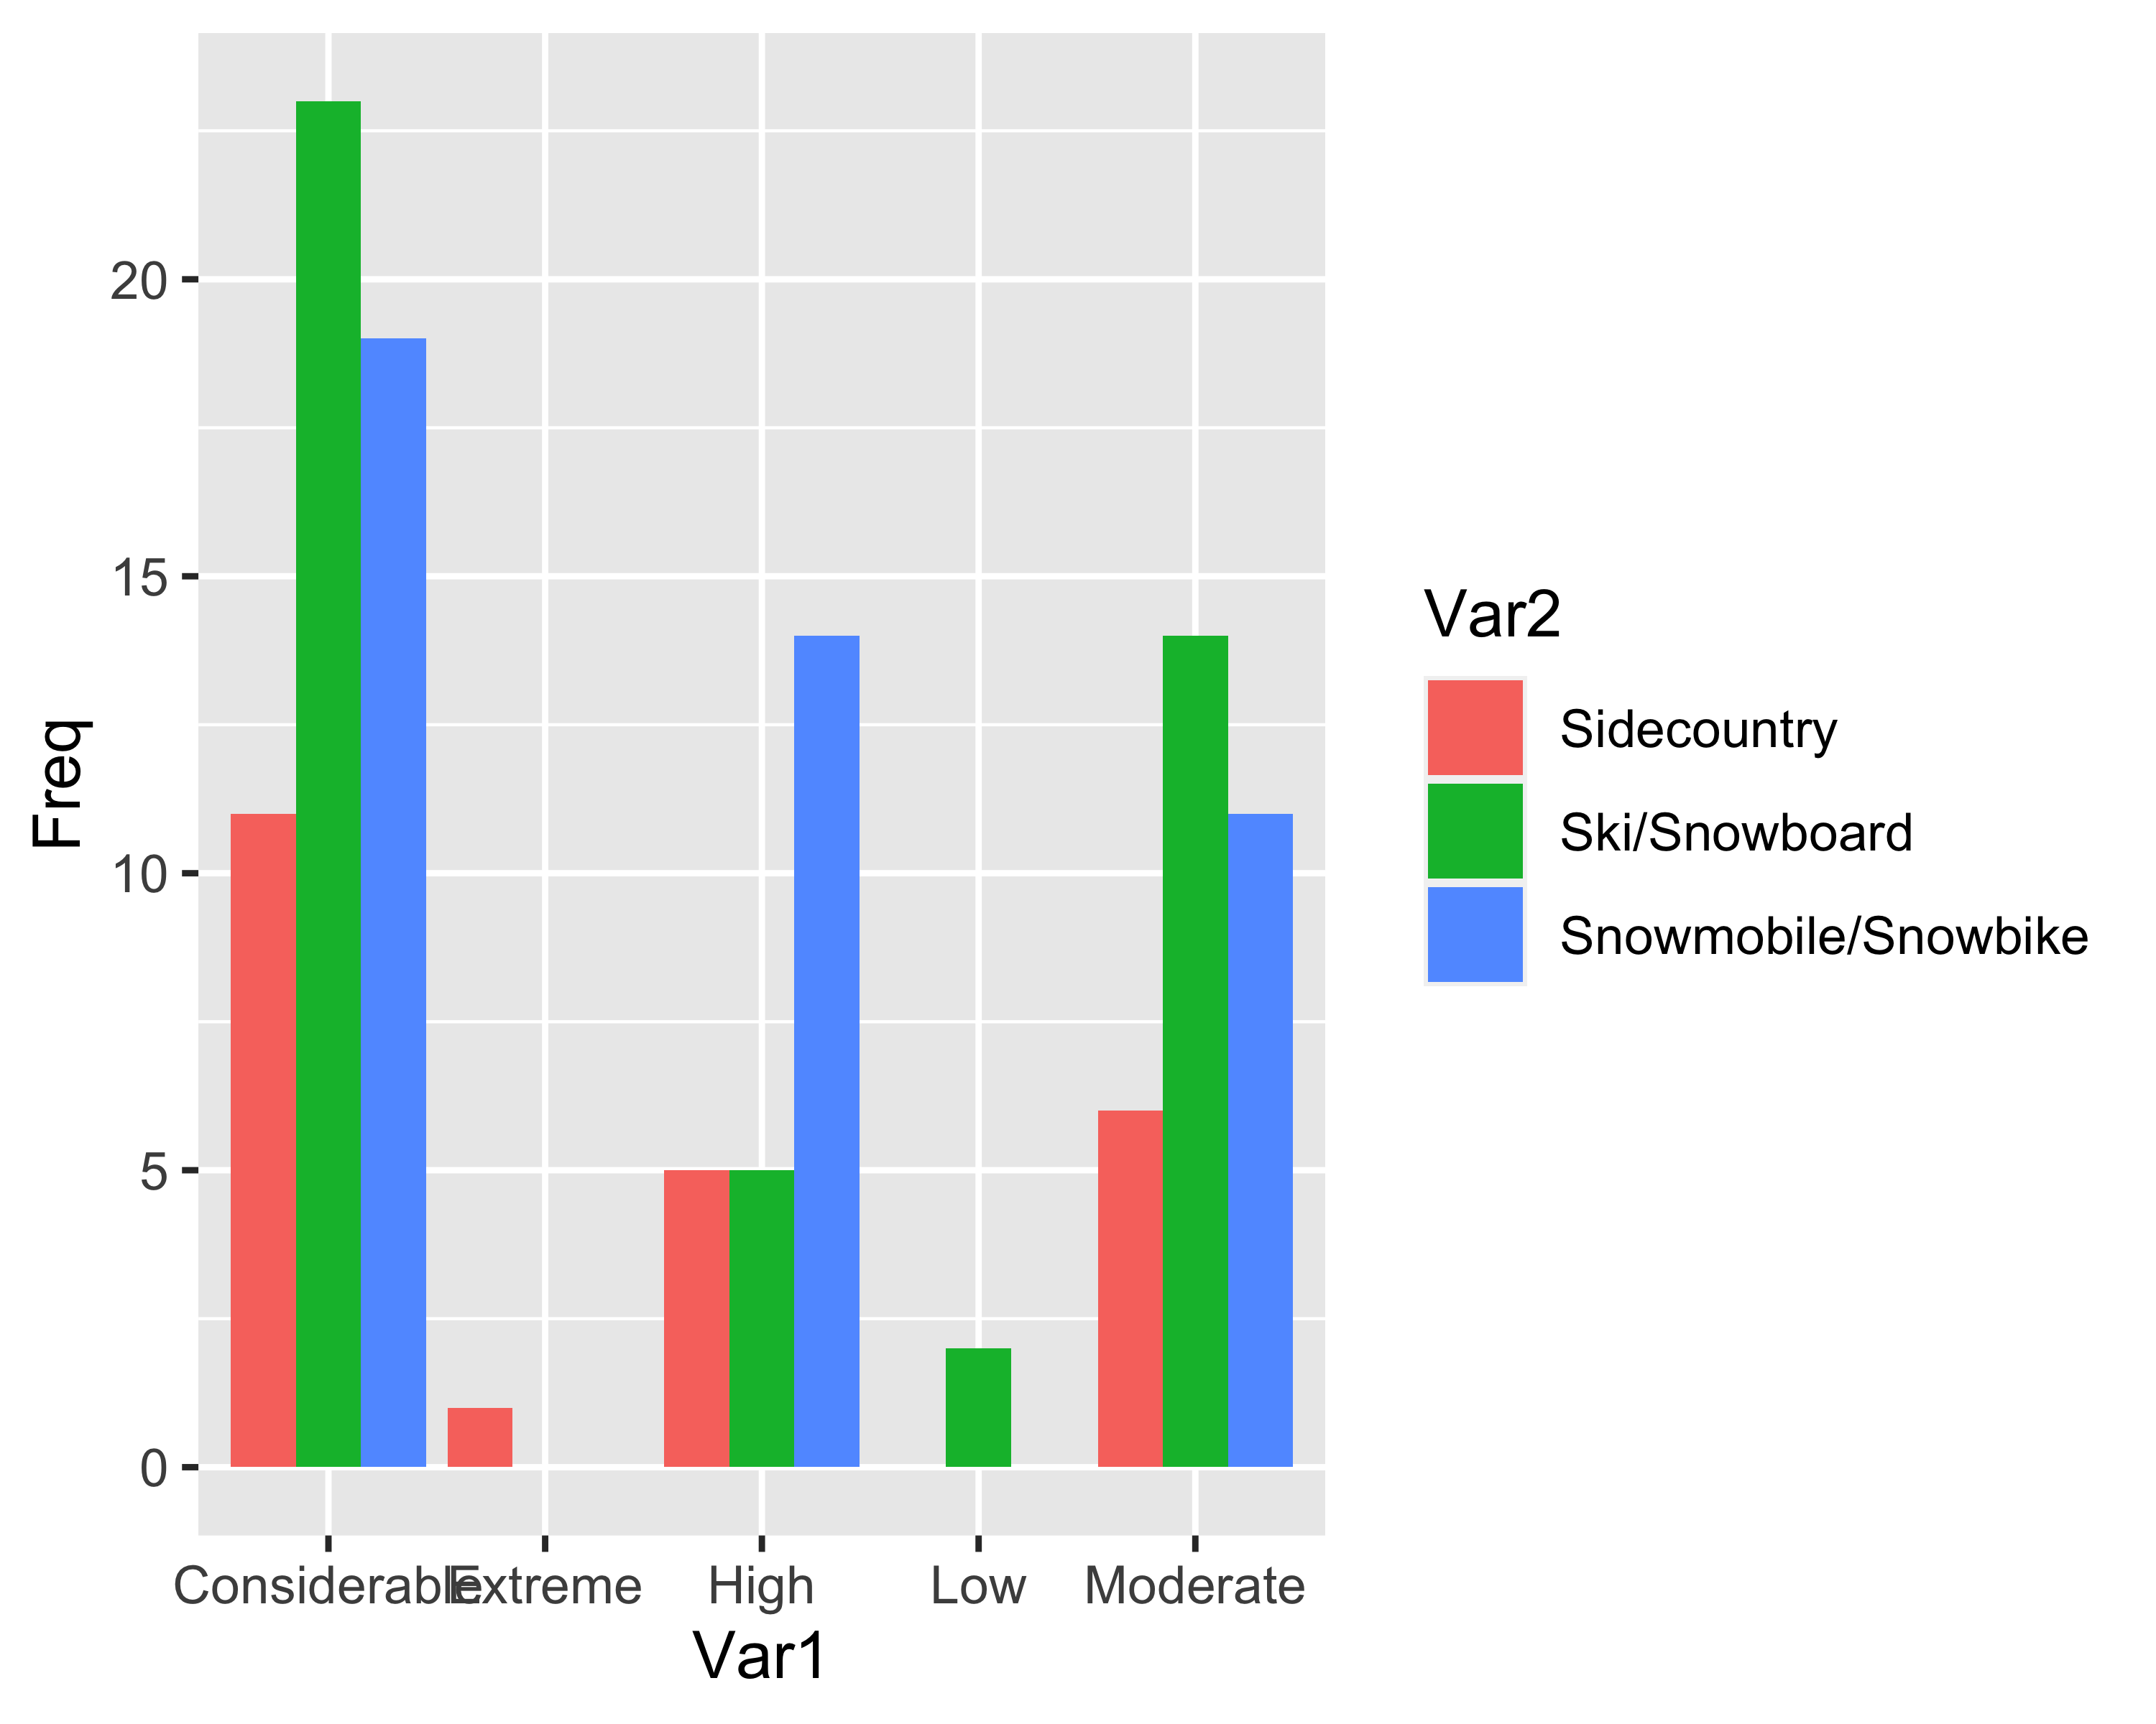

## Comments

1. Based on the results I would inclined toward Preparedness score 3 and one-way anova result and present the two-way anova result as sanity check.
2. Analysis on burial time is still incomlete. I would spend couple of hours next weekend to do something more.
3. Please send me specifict questions (I think we have already discussed some, please remind me). Specific questions will be very helpful for me when I analyze the data.

## Analysis after edit

### Preparedness 4 / Model 2

Bartlett test (p-value = 0.20) did not suggest violation of homogeneity of variance assumption while the Fligner-Killeen test did (p-value = 0.024). We fit a classical ANOVA and Welch’s ANOVA model.

#### Classical ANOVA

## Df Sum Sq Mean Sq F value Pr(>F)   
## Tourer 2 410.7 205.4 21.739 2.89e-09 ***  
## Total_in_party_cat_bin 1 556.2 556.2 58.880 7.34e-13 ***  
## Tourer:Total_in_party_cat_bin 2 13.3 6.6 0.702 0.497   
## Residuals 199 1879.8 9.4   
## ---  
## Signif. codes: 0 '***' 0.001 '**' 0.01 '*' 0.05 '.' 0.1 ' ' 1

### Welch’s ANOVA

##   
## One-way analysis of means (not assuming equal variances)  
##   
## data: Preparedness4 and Tourer * Total_in_party_cat_bin  
## F = 45.744, num df = 5.00, denom df = 17.83, p-value = 1.49e-09

Both of the models concluded that the preparedness score (Model2) differs significantly between the tourer groups (classical ANOVA p-value = $7.34×{10}^{−13}$, Welch’s p-value = $1.49×{10}^{−9}$).  
### Tucky HSD post-hoc analysis

Tucky HSD test reveals that every tourer groups has significantly different preparedness from each other.

## Post-hoc analysis for other preparedness scores

Comment: We don’t have enough evidence to conclude significant difference in preparedness(1) between Snowmobile and sidecountry. There is strong evidence to conclude that ski vs sidecountry and snowmobil vs ski are significantly different.

No post-hoc test is done for Preparedness2 as the ANOVA concluded no significant difference.

Ski vs sidecountry - significant Snowmobile vs sidecountry - significant snowmobile vs ski - we don’t have evidence to conclude significant difference